Shabbos stories anthology for chanuka
Compiled by Daniel Keren
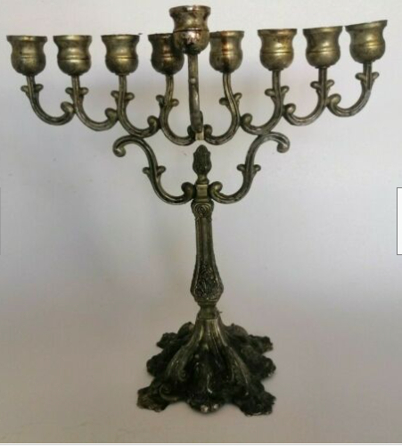
Shabbos Stories for Parshas Mikeitz 5775……...Page 2
Shabbos Stories for Chanukah 5777……………Page 4

Shabbos Stories for Chanukah 5777 – Part 2…Page 18

Shabbos Stories for Chanukah festival 5778….Page 35

Shabbos Stories for Chanukah 5780…………..Page 59
Shabbos Stories for
Parshas Mikeitz 5775
Volume 6, Issue 14 28 Kislev 5775/ December203, 2014
Printed L’illuy nishmas Nechama bas R’ Noach, a”h

For a free subscription, please forward your request to keren18@juno.com

It Once Happened

In the Merit of Matitiyahu, Father of the Macabbees

A huge group was gathered on the other side of the large table and looked in the direction of their rebbe, Rabbi Avraham Wienberg, the Slonimer Rebbe. He stood opposite the wicks in the Chanuka menora, meditating and contemplating, for an unknown reason not yet ready to kindle the Chanuka lights.
Hundreds of Chasidim stood in awe and with great respect, watching their Rebbe as he stood preparing for this mitzva. They waited with bated breath for the glorious moment when he would take the wax candle in his hand and begin reciting the words of the Chanuka blessings.
Minutes, which seemed like hours, passed and then the Rebbe began chanting the blessings. He infused each word with kabbalistic intentions, and each chasid there was able to hook into the holiness of the moment according to his own level.
"Help me, deliver me!"
The dreadful cry tore through the hearts of all those gathered there and awakened each person from his reverie. Everyone looked in the direction of the voice.
The Rebbe, his face aflame with the holiness of the moment, also turned his head in the direction of the voice toward the end of the synagogue. There stood a women with her hands outstretched toward the heavens, crying with a bitter heart.
It became clear that this woman was not one of the wives of the chasidim gathered there. In fact, she had no connection to the Rebbe or the Chasidic lifestyle. "Who was she?" some murmured.
The distraught woman lived with her family in this town. Her husband was a wealthy and well-respected businessman who had never in his life entered this Chasidishe synagogue. He and his friends were among those who laughed at the Chasidic lifestyle and customs.
For many years the couple had not been blessed with children. When their son was finally born they were already much older. Their happiness knew no bounds. He was always given the best of everything, though he was not especially spoiled.
On the eve of Chanuka the young boy fell ill. The doctors came to his bedside and cared for him with devotion. But they could not help him. To everyone's horror his fever rose from day to day. Tonight, his situation worsened. The boy lost consciousness and the doctors who were standing around his bed raised their hands in hopelessness.
The father of the child was pacing around the house in agony and bitterness. But his mother could not stand seeing her son's suffering any longer and left the house. Suddenly she began walking quickly. Toward what or where or whom she knew not. But her feet seemed to have a mind of their own, and before she knew it she found herself in front of the Slonimer synagogue just as the Rebbe was preparing to kindle the Chanuka lights.
"Rebbe, help me," cried the woman in a voice that echoed throughout the entire synagogue.
"Tell her not to worry," the Rebbe said quietly to someone. "She should go and return home. She should ask her husband to add to her son's name the name 'Matitiyahu' [Matithias]. And in the merit of that great tzadik--father of the Macabbees--who gave up his life for the Jewish people and the Holy One, the sick child's life will be lengthened. And another thing, when the child is fully recovered, his father should bring a 'pidyon nefesh' of chai--life--18 coins which will be given to charity in the Holy Land."
The following day, at about the time when the Chanuka candles were being lit, a new face was seen in the Slonimer synagogue. It was the father of Matitiyahu, who had brought to the Rebbe 18 rubles, a pidyon nefesh for his son who was fully recovered, to the Rebbe.

Reprinted from the Archives of L’Chaim Weekly (Issue #227 – Parshas Mikeitz – December 1992).

Shabbos Stories for
chanukah 5777
Volume 8, Issue 15 25 Kislev 5777/ December 25, 2016
Printed L’illuy nishmas Nechama bas R’ Noach, a”h

For a free subscription, please forward your request to keren18@juno.com

The Miracle of
Bubbie's Menorah
By Eli Hecht

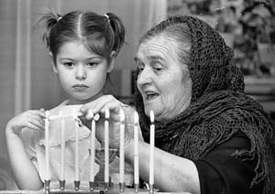

My sweet grandmother is a small woman, barely five feet tall. Her two feet tall candelabra was more than just a candle-holder. It was a family symbol, a magnet that brought us all together.
On Shabbat evenings Bubbie would don a special Shabbat kerchief. With great fanfare she would light each candle. When she finished lighting the last candle, she stood in front of the candelabra and closed her eyes. Tears ran down her cheeks. She prayed for her husband, her married children and her grandchildren. She spoke in Yiddish, "Her mein tier tata, hiet oif mein man, kinder un di eyniklach...." (Dearest Father in Heaven, watch and protect my husband, children and grandchildren. May it be your will that they grow up to be good people who are loyal to our religion. Please grant my dear husband a livelihood and patience. Watch over us all.)
We all stood by the Shabbat table in awe. Bubbie looked like a queen speaking to the King of Kings, the Almighty G-d. When she finished her prayer, we began our Shabbat.
As our family grew, Bubbie spent more time with her candles. By the time she reached her 94th birthday, she had many married grandchildren, who also had children of their own. There were five generations in Bubbie's family. When lighting the candles, Bubbie prayed for each family member.
Her candelabra was made of solid silver with a heavy silver base. All year-round it had three branches of two candlesticks. In the middle was a stem for another candle. The traditional custom for Shabbat eve is to light one candle each for the father, mother and children. As each child is born, another candle is added to the Shabbat lighting. Throughout the year Bubbie's candelabra was fitted for five candles.
During the week of Chanukah, she added another branch of two candlesticks each, making a total of nine candles. The candelabra was built in such a way that the candle holders could be removed and oil cups could be inserted for the special lighting on Chanukah. Our Shabbat candelabra became a Menorah.
During the week of Chanukah she gave her prized candelabra to my grandfather to light candles for the holiday. Chanukah was our happiest time. All the children, grandchildren and great-grandchildren came to Bubbie and Zaydie to receive Chanukah gelt and join in the Menorah lighting.
Imagine the two-foot menorah with nine candles shining in all its glory. Zaydie stood proudly like a Kohain, the high priest in the temple, when he lit the menorah.
When Zaydie died, Bubbie would spend her winters in Miami Beach. She took her candelabra with her. Every Shabbats Bubbie would shine the silver candelabra and pray, "May my mazel (luck) always shine!"
All this came to an end when someone stole her menorah. Bubbie was livid. Her small body shook like a willow in the storm as she spoke about her most prized possession, her candelabra. How could anyone steal it? Her only concern was how she would light her candles.
She believed the menorah would return. "I have prayed that the menorah would protect us, and I'm sure that the menorah has done just that. Now I pray that the menorah protect itself and be returned to me."
With silent determination she prayed and prayed. The family did not know what to do. Unexpectedly a childhood friend from Austria, Bubbie's birthplace, once visited us and announced, "I never saw another menorah like yours until today. Surprisingly I saw a replica of your menorah, in the window of a gift store."
We were dumbfounded. Could it be that our guest had seen the stolen menorah? Bubbie jumped back and said, "Let's get my menorah back! It soon will be Chanukah and I need the menorah back."
Bubbie, my parents, Bubbie's girlfriend, and a policeman made their way to the gift shop. With a gleam in her eyes and a shout of joy Bubbie pointed to her menorah and said to it, "Yes, you have done well. You have protected us and now you have protected yourself. Come back home with me."
Before anyone could say anything, Bubbie grabbed the menorah off the shelf and held it close to her heart. Nobody could stop her. Neighbors, Jewish and non-Jewish, joined Bubbie in her triumphant walk home. The closer she neared home, more and more people joined her. Bubbie, dressed in the European manner, with her slight frame carrying a menorah almost as big as her, followed by a procession of excited family and friends, was a sight to see. It truly was a grand Chanukah parade.
The menorah was given a special cleaning, and that Chanukah was the brightest in Bubbie's home. Who says that miracles don't happen anymore?

Reprinted from the Chanukah website of Chabad.Org

MODI’IN — FORTRESS OF THE HASMONEANS

The modern city of Modi’in founded in 1994, and the religious community of Modi’in Ilit (Kiryat Sefer) nearby, recall one of the miracles of Chanuka now being celebrated by Jews throughout the world. As we say in the special prayer of that day, “It was in the days of Matityahu, son of Yochanan the Kohen Gadol, the Hasmonean, and his sons” that the miracle of “the mighty and numerous Greek forces” bent on forcing assimilation were overcome by “the weak and few”. Mount Modi’in was the place where the Hasmoneans rallied their outnumbered forces and with the help of Heaven achieved victory over their oppressors. (OHRNET)

Chanukah – Lighting Left
By Rabbi Yirmiyahu Ullman

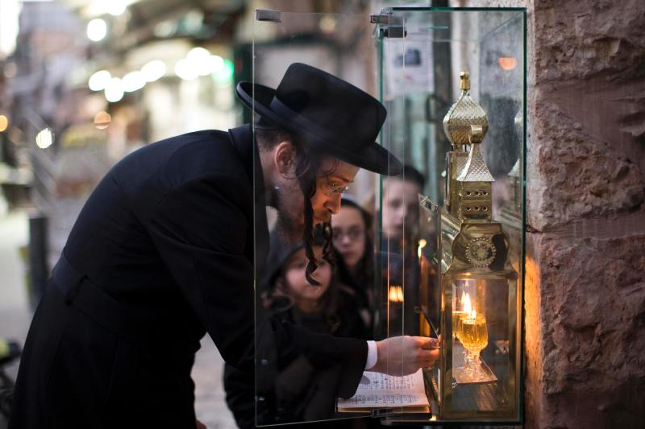
A man lighting a Chanukah Menorah in Yerushalayim

From: Chava

Dear Rabbi, It seems to me that the right side is usually given precedence in performing mitzvot. Why is the Chanukah menorah lit on the left side of the doorway?

Dear Chava, Many people nowadays light inside the house either on a table or near the window. But it is correct that according to the original halacha, and as still practiced by many today, the ideal location to light the Chanukah menorah is on the left side of the main, outer doorway into the house.
One reason that’s given in the sources is in order that a person will be encompassed by mitzvot — by the mezuzah, whose place is fixed on the right, and the menorah, which is therefore placed on the left. In this way, a person’s goings out and comings in are illuminated by the spiritual and physical light of the mezuzah and the menorah.
In addition, the verse states, “There is length of days in its right hand; in its left there are wealth and honor.” “Length of days” refers to the World-to-Come, which was given to Israel. “Wealth and honor” belonged to Yavan (ancient Greece), the descendent of Yefet. But when the Greeks tuned to evil, Israel merited their portion as well. Hence we have the mezuzah, which mentions length of days, on the right; and we light the menorah to symbolize our victory over Greece on the left, expressing our hope to receive their wealth and honor for the purpose of serving G-d.
Another idea is that since the doorway serves for entry as well as departure, while the menorah is on the left of the doorway going in, it illuminates the right side going out. That is to say, this lamp sheds light upon us even when we are “outside”, in exile among the nations of the world. And even now, while the Temple is not built, the light of the Chanukah menorah illuminates our path in exile.
In a similar light, the original altar was consecrated on the 25th of Kislev, the same day on which Chanukah was later instituted. The mitzvah of making a sanctuary for G-d in which He may dwell in our midst is thereby timeless, and every Jew is obliged to yearn daily for the rebuilding of the Temple.
One way we do this is by lighting the Chanukah menorah in memory of the miracle that occurred during that rededication of the Temple. And we place it facing outward on the right — like a person on vigil waiting at the door in anticipation of a long-expected wayfarer’s return. May we merit the arrival of Mashiach and the restoration of the Final Temple speedily in our days, Amen!

Reprinted from the 5776 Chanukah email of OHRNET, the Ohr Somayach Torah Magazine of the Internet.
Chanukah, 1942
By Carola Schiff

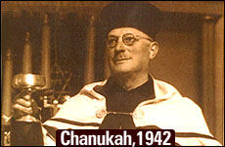

Spreading the light in Nazi-occupied France.

My father, Reb Meir Shlomo Sommer, Monsieur Sommer as he was called in France, was a man of uncompromising faith, conviction and courage. He was the principal of a Jewish Day school in Hamburg/Altona, Germany until Kristallnacht, when the Nazis closed the school. In July 1939, my father and mother were able to flee to France on a two week tourist visa to escape the Nazi reign of terror. In France both my parents were interned, separately, in various detention and labor camps. By Divine miracle, they were both released and reunited in October 1940.
Since they were Jewish refugees from Germany, they were considered a threat to France and were forced to go into hiding in the outskirts of Perigueux, a small town in southwestern France.
In 1942, at the height of the Nazi reign of terror, there were constant "Raffles" – Jews would be summarily rounded up and sent to horrible detention camps and from there to the infamous death camps of Eastern Europe. Curfew times were enforced and no one was allowed on the streets at night. It was a constant struggle to find hiding places to evade the Nazis and their French collaborators.
"From a population of about 330,000 at the end of 1940, nearly 80,000 Jews had been deported or murdered in France. They represented more than 24 percent of the Jewish community." (The Holocaust, The French, and the Jews, Susan Zuccoti p.207).
During their internment and in hiding, my parents clung to their faith with tenacity. Against all odds, my father maintained his strong Torah principles, never compromising on Kashrus, Shabbos or Jewish holidays. He was a man of strength and kindness. He was filled with love for his fellow Jew, and always tried to help others in need. He would regularly ignore the war-imposed curfew, and at the risk of his life, braved the terror of the Nazis in order to teach Torah to Jewish children in hiding.
After the war, my father was the spiritual leader in Vichy, France. Shortly after his untimely death in 1956, we received the following condolence card highlighting how my father managed to spread the light of Chanukah during the darkest time in Nazi-occupied France:

Chanukah 1942
1942 in Perigueux, France, a few men hurried into a rundown wooden barrack. Each opened the door carefully looking around to make sure they weren’t being followed. They then went into a hidden backroom. This room served as the makeshift Shul for those brave enough to venture out. The "shul" barely scraped together a minyan of men to pray.
They davened Maariv quickly, their hearts rapidly beating with the knowledge that at any moment the Nazis could storm in and arrest everyone. One man lit the menorah as the others ran to grab their coats and get home as fast as possible.
Suddenly, a man in the back of the room stood up and in a deep, warm voice started to sing “Maoz Tzur.” The men were frightened and aghast. Someone might hear; it was too dangerous! Soon another man joined in singing, then another and another, until everyone was tearfully and courageously singing with joy. For the moment, gone were the fears of the Nazis. For a few moments, Chanukah was there in all its glory, as in days of Judah the Maccabbe, a few brave men stood proud, their faith prevailing over the evil surrounding them.
The man who stood to sing was my father, Reb Meir Shlomo Sommer known to all as Monsieur Sommer, of blessed memory. My father had never told anyone of us his Chanukah victory during those dark time, yet even after his death, this story continues to inspire light.

Reprinted from the Chanukah website of Aish.com
Sufganiyah – To Eat or Not to Eat, That is the Question!

Why Jelly Doughnuts Are
Eaten During Hanukkah
By Emelyn Rude

It's not just a matter of celebrating with foods cooked in oil

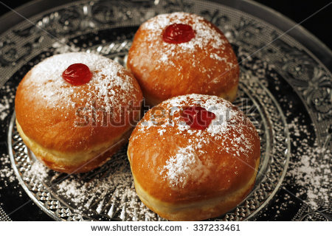

The Israeli version is the sufganiyah—the singular of sufganiyot—and it’s not only the L-rd’s consolation prize, but also a staple of annual Hanukkah celebrations. It’s said that the fried treats are a good fit for a holiday focused on oil, commemorating the miracle of one night of oillasting for eight. The most stereotypical sufganiyot, after all, are fried balls of yeast dough filled with strawberry jelly and dusted heavily with powdered sugar.
But jelly doughnuts weren’t a part of a typical diet at the time the Hanukkah story would have taken place, and the miraculous oil isn’t the whole story behind why they’re eaten on the holiday.
The word sufganiyot can be traced back to the Greek word sufan, meaning “spongy” or “fried,” as can the Arabic word for a smaller, deep-fried doughnut named sfenj. This could perhaps be where these treats got their name; similar fried balls of dough have been eaten to commemorate Hanukkah for centuries by Jews in North Africa.
But these Moroccan and Algerian treats didn’t have the modern sufganiyot’s characteristic jelly filling, which is where migrants from Central Europe came in. The first fried pastries in European history typically contained savory fillings, like meat or mushrooms. But the establishment of colonies in the Caribbean in the 16th century brought cheap, slave-produced sugar to the continent and led to a renaissance in fruit preserves and from that a renaissance in sweet stuffed pastries.
The first known recipe for a jelly doughnut, according to historian Gil Marks, can be found in the 1532 German cookbook Kuchenmeisterei, which translates to “Mastery of the Kitchen” and is remembered by history for being one of the first cookbooks run off of Gutenberg’s famed printing press. The treat was made by packing jam between two round slices of bread and deep-frying the whole thing in lard.
From its Germanic origins, the dessert quickly conquered most of Europe. It became krapfen to the Austrians, the famous Berliners to the Germans and paczki to the Polish. Substituting schmaltz or goose fat for the decidedly un-Kosher lard in their fryers, the Jewish peoples of these regions also enjoyed the dessert, particularly Polish Jews, who called them ponchiks and began eating them regularly on Hanukkah. When these groups migrated to Israel in the early twentieth century, fleeing the harsh anti-Semitism of Europe, they brought their delicious jelly-filled doughnuts with them, where they mingled with the North African fried-dough tradition.
But it would take more than just the mingling of Jewish cultures to make the sufganiyot the powerful symbol of Israeli Hannukah it is today. Credit must be given to the Israeli Histradut. Founded in 1920 in what was then British-mandated Palestine, the national labor group’s aim was to organize the economic activities of the Jewish workers in the region. Founded on Russian socialist principles, full employment was amongst its aims, as was the integration of the new Jewish immigrants making their ways to the country’s shores.
The latke, the classic fried potato pancake that was already associated with Hanukkah celebrations, is a dish that can easily be made at home. A perfectly filled and fried sufganiyot is much more difficult. Even some of the most talented at-home cooks will agree that the treat tastes better when left up to the professionals. Which is exactly what the Histadrut wanted: a Hanukkah treat that involved professionals. As many important Jewish holidays are concentrated in autumn, the end of that season often brought a lull in work in Jewish quarters.
By pushing the sufganiyot as a symbol of the Festival of Lights, as opposed to the DIY-friendly latke, the Histradut could encourage the creation of more jobs for Jewish workers.
By all accounts, the Histadrut’s efforts to promote the jelly doughnut worked. In modern Israel, over 18 million sufganiyot are consumed in the weeks around the holiday, which averages out to over three doughnuts per citizen. More people enjoy the fried treat than fast on Yom Kippur, the holiest day in the Jewish calendar, and the Israeli Defense Forces purchase more than 50,000 of the doughnuts each day of the eight-day holiday to boost the morale of its troops.
Sufganiyot can now be found throughout the United States as well during Hanukkah, produced by Jewish and non-Jewish bakeries alike. After all, as people all over the world have been discovering for centuries, no one can say no to a truly delicious jelly doughnut.
Emelyn Rude is a food historian and the author of Tastes Like Chicken.

Reprinted from the December 7, 2015 edition of TIME Magazine

Israeli Health Minister Declares ‘Donuts – Out!’
By Times of Israel Staff

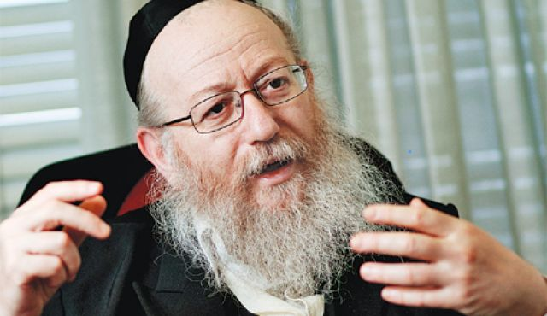
Health Minister Yaakov Litzman at a press conference at the Health Ministry in Jerusalem, on November 21, 2016. (Photo by Hadas Parush/Flash90)

[Rabbi] Yaakov Litzman says Israel must find alternative to sugary, oily Hanukkah treat, educate children to eat better. Health Minister Yaakov Litzman has urged Israelis to eat fewer sufganiyot, the oily jelly donuts traditionally eaten during Hanukkah — and in recent years in Israel, for weeks beforehand — as part of his crackdown on unhealthy food.
Litzman, of the ultra-Orthodox United Torah Judaism party, who in the past criticized the amounts of junk food eaten in Israel, and specifically called out fast-food giant McDonald’s, has now found another target, the Kikar Hashabat news site reported Sunday.
“When I said that we should cut down on McDonald’s, they thought I’d gone crazy,” Litzman told a healthy lifestyle forum. “If I would have said it today, I would have said, ‘Sufganiyot – out!'”
Litzman said that there are many healthy, alternative ways of celebrating the festival which should be encouraged.
“We can find alternatives and we don’t have to feed our children donuts which do not match health values and proper nutrition,” he said. “Obviously we can eat them, since they are part of our tradition, but there are better substitutes. I call on the public to avoid eating donuts which are full of oil.”
Litzman was speaking at a conference led by Professor Itamar Raz, head of the National Council for Diabetes.
In March, Litzman controversially attacked McDonald’s, saying that “there is no need to eat junk food, not in our country.”

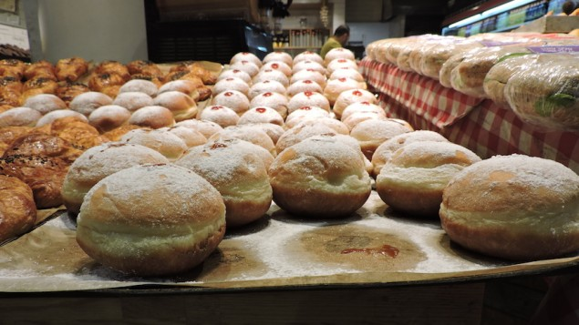
He urged parents and educators to teach children not to eat junk food and sweets and stressed that the Health Ministry would focus on “preventative” medicine this year to curb disease.
Now the minister may have bitten off more than he can chew in attacking these winter treats. Jelly donuts are very popular in Israel, where an array of flavors is featured at bakeries, supermarkets, coffee shops and restaurants beginning as early as October.
The Festival of Lights, which commemorates the Maccabean revolt against the Greeks, has long featured oily foods such as latkes and donuts in remembrance of the miracle of the temple oil, which lasted eight days instead of the expected one.
Jelly-filled donuts typically have around 375 calories per 100 grams. However, just days ago Burger King announced that, this Hanukkah, it will be offering a version of its Whopper burgers served on the traditional sufganiya.
The American fast food chain said the “Sufganiking” will be on sale at all Burger King chains in Israel starting on December 25, the first night of Hanukkah, until January 1st, and will cost NIS 14.90 ($4.00).

Reprinted from the December 12, 2016 edition of the Times of Israel.

The Story of Chanukah in Brief

REMEMBERING LIGHT
During the time of the 2nd Temple, the Holy Land was ruled by cruel Greeks. They robbed the Jews of their property, and set up idols in the Beit HaMikdash. No one could stand up against them, till Mattityahu and his sons rose up and drove them from the land. The Chanukah lights remind us of the great miracle that a small band of Jews defeated the mighty Greek armies.

FIGHTING FOR LIGHT
The Greeks were philosophers. They accepted the Torah as a book of wisdom, but not as something holy that connects us to Hashem. In the end, they made Torah learning illegal, and outlawed Mitzvot like Shabbat, Rosh Chodesh, Brit Milah, and the holiness of Jewish marriage. The Maccabeesrisked their lives to keep Torah alive! That’s why they won!

THE MIRACLE OF LIGHT
An even greater miracle than defeating the Greek armies was the miracle of the oil. The Greeks had made all the oil in the Beit HaMikdash impure. Miraculously, the Maccabees found one jar that had been overlooked. But it only had enough oil for one day. So great was their love of G-d, that they lit it anyway! Hashem made another miracle, and the oil burned for eight days! Everyone could see that the Shechinah dwelt with the Jews.

JOYOUS LIGHT!
With tremendous joy, the Jews cleansed the Beit HaMikdash and began to serve Hashem once again! Nowadays, we have to draw on that joy, because the darkness has grown very great! That's why we make Chanukah parties, with dreidels, latkes, and Chanukah gelt. Joy has the power to overcome any negative thing, and break any evil decree!

ADDING LIGHT!
Every day of Chanukah we add another candle till all eight candles of the Menorah are ablaze. By adding a candle every night for 8 days, we charge ourselves up with light, so that we will constantly be adding in Torah and Mitzvot (which are compared to light), throughout all the days of the year to come.

HOLY LIGHT!
The light of the Chanukah candles is holy, like the light of the Menorah in the Beit HaMikdash. We are careful not to use it for any purpose — our Mitzvah is just to look at the candles and listen to the story that they tell.

FILLING THE WORLD WITH LIGHT!
The miracle of Chanukah occurred in a dark time when there were wicked decrees against the Jews. But the Maccabees had courage and never lost hope. Their mesirut nefesh (self sacrifice) turned the darkness into light! Today too, our mesirut nefesh for Torah and Mitzvot will light up the world and bring Moshiach Now!

Reprinted from the website of JewishKids.org

Shabbos Stories for
Chanukah 5777 – Part 2
Volume 8, Issue 17 2 Teveth 5777/ December 31, 2016
Printed L’illuy nishmas Nechama bas R’ Noach, a”h

For a free subscription, please forward your request to keren18@juno.com

A Slice of Life
"Hizzoner" and
Two Menoras
By Rabbi Yosef Landa

I was listening to the radio the day Ed Koch passed away, when I heard a recording of the former New York City Mayor answering a reporter's question about how he would like his epitaph to read.

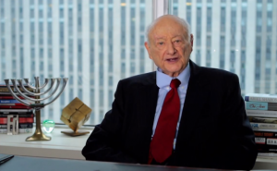
The late Mayor Ed Koch of New York City
with a Menorah in the background.

In his inimitable style Koch responded without missing a beat. "He was fiercely proud of his Jewish faith and he fiercely loved the City of New York," he said. I was totally impressed. Here was a wonderful manifestation of the "pintele yid," that inexhaustible Jewish essence which is at the core of every Jew. It was noteworthy, I thought, how Koch had mentioned his pride in his Jewish identity first, ahead even of his love for New York.
I recalled how over 30 years ago while serving as Mayor, Koch helped some of my fellow Jews in St. Louis - may G-d bless them and keep them - to learn an important lesson. Koch probably never knew what he accomplished that day, and I never had the opportunity to thank him for it. So I'll share the story here as my belated expression of gratitude to "Hizzoner" the Mayor.
Young, idealistic and inexperienced, my wife, Shiffy, and I had just moved to St. Louis a few months earlier to establish Chabad in this mid-size Midwestern Jewish community of about 50,000. One of our earliest community-wide projects was to erect a fifteen-foot Chanuka menora on the plaza of the St. Louis County Government Center. The county executive happily approved the menora display and even joined us for the beautiful lighting ceremony. The TV and news reporters were present and provided ample media coverage. We received many wonderfully supportive comments from the public, Jews and non-Jews alike, telling us how the menorah was a tasteful and fitting expression of Jewish celebration and pride, and of the religious diversity which is this country's blessed hallmark.
Much to our surprise and dismay, the menora display also encountered fierce opposition, which emanated largely from the professional leadership - well meaning, I am sure -- of an array of local Jewish establishment organizations. Their argument was ostensibly that they considered the placement of the menora on public property to be in violation of the constitutional separation of church and state. It was evident, however, that there also was an underlying unease with the forthright, unabashed public display of Jewishness which the menorah represented, and which many Jews in this conservative city, in the middle of America, were unaccustomed to at the time.
These were well-intentioned people who were firmly attached to what they perceived to be the Jewish community's sacred opposition to such displays. Some saw us as foreigners, "imports from Brooklyn" (that's how one writer referred to us in an op-ed), who had come to town to overturn long-standing, hallowed community norms. The county executive, to his great credit, remained firm in his support of the menorah display, and the entire community was abuzz over this controversy. The local Anglo-Jewish newspaper made it front-page news and editorialized against us, and word of the discord within the Jewish community even reached the general media. It was not a pleasant situation, to say the least.
A lot has changed since then. We have become good friends with many of the people who initially opposed us, and Chabad now enjoys deep and fruitful relationships with individuals and organizations from throughout the community. The public Menora has become a commonplace and accepted feature in many cities across the country. Moreover, in a couple of landmark rulings the U. S. Supreme Court gave its nod to this sort of "holiday display" on public property. Eventually American Jewish organizations came around to recognize that there exists a constitutional argument in support of such displays as well, namely the protection of our religious freedom and of free speech. But our story happened well before that.
It was the last day of Chanuka that year, and the iconic, big city Mayor Ed Koch happened to be in St. Louis to address the annual meeting of the local Jewish Federation which was held over a Sunday brunch at an upscale St. Louis hotel. Several hundred supporters were in attendance, including many of the professional and lay leaders who were heading the opposition to the menorah. Koch gave his speech, which of course had nothing to do with the menorah, and then proceeded to take questions from the audience.
That's when one questioner took to the floor and asked Koch to explain how, as a Jewish mayor, he dealt with the issue of religious symbols on public property and, specifically, would the mayor be kind enough to share his own view about the placement of menorahs on public property.

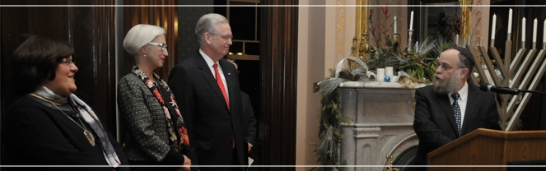
From right to left: Rabbi Yosef Landa, Missouri Governor Jay Nixon, First Lady Mrs. Georganne Nixon and Rebbetzin Shiffy Landa at the 2013 Festival of Lights (5th Night of Chanukah) that was celebrated with a lighting of the Menorah and a Chanukah Party at the Governor’s Mansion in Jefferson City, Missouri.

An audible gasp went up from the audience. Someone had dared to bring up the embarrassing, unmentionable topic of the menorah display in the presence of this important guest. Then there was utter silence as the straight-shooting Koch responded in his typical direct and outspoken manner. "I have no problem whatsoever with having a privately-funded menorah on public property", he said. "I think it's absolutely wonderful. I'm proud to say that we have one in New York City at Fifth Avenue and Central Park" he continued.
As if he hadn't said enough on the subject, the Mayor continued further. "Let me tell you what else we do in New York," he said. "The menorah is in Manhattan. The people who light the menorah are the Lubavitchers. They live in Brooklyn. So when they light the menorah in Manhattan late on Friday afternoon when it's getting close to Shabbos, we provide them with a helicopter and we fly them back to Brooklyn, so they can get home in time for Shabbos!"
Nothing more needed to be said. That was the end of the problem. While I'm sure most people in the audience didn't change their minds about the menorah display and the First Amendment just because of what Koch had said, he nonetheless succeeded to make everyone understand that good and decent people within the Jewish community can hold differing views on such matters.
While doing so, he not only quieted a controversy regarding church-state separation, but more importantly, he let my fellow Jews in St. Louis see a wonderful first-hand example of real, unapologetic Jewish pride. He reminded them that there's no reason in this great country for anyone to hide their Jewishness as if it were contrary or inimical to American life and culture. And for that I am most grateful. Thank you, Mayor Koch.

Reprinted from last year’s Miketz 5775 edition of “L’Chaim,” a publication of the Lubavitch Youth Organization in Brooklyn, NY. ,Rabbi Landa is the director of Chabad of Greater St. Louis, in Missouri

When Levi Yitzchak of Berditchov Wished His Kehillah Blessings for
The New Year on December 31st

It was late at night one New Year’s Eve, December 31, and the beis medrash of Rav Levi Yitzchak of Berditchov was still filled with his chasidim who were sitting and learning. Close to midnight, the door to the private office of the Rav, which was adjacent to the beis medrash, opened, and the Rav shouted out to his Chasidim: תכתבו טובה לשנה ותחתמו, ‘May you be inscribed and sealed for a good year!’ He then returned to his office and closed the door behind him.
The chasidim were mystified. Didn’t the Rav know that this was the secular New Year and not the Jewish New Year? A short time later the same thing happened and the Berditchover Rebbe came out to bless them. And then this happened again for a third time.
The chasidim were totally baffled! As not just anyone could approach the Rav, the men asked an elderly chasid to approach him and ask for an explanation. The Rav told the elderly man the following: The previous Rosh Hashanah, the tefilos and shofar blowing of the city of Berditchov were especially beautiful and heartfelt and went directly to Heaven. Hashem was so taken by these tefilos that He immediately inscribed the entire city in the Book of Life and bestowed on each and every one of them a year of health and wealth.
When Yom Kippur came, Hashem was so taken by their fasting and crying. The people poured out their hearts into their prayers. Hashem was about to seal the inscription that He had written on Rosh Hashanah, when suddenly the Satan spoke up.
“True, the people have been praying fervently, but, this is only one day! How can You inscribe them favorably for an entire year based on their actions of only one day?"
Hashem therefore held back and the inscription was not sealed. Immediately after Yom Kippur, the people started to build their succos in preparation of the upcoming Yom Tov. The defending angel spoke up, “Hashem, see how Your people are involved in doing the mitzvah? Even the poor people are building their succah to the best of their abilities!”
The Satan was not to be deterred. “Again, I object! True, they are building succos for You. But, look at the houses they live in, permanent structures of brick, stone and glass. But for You, Hashem, they merely build temporary shacks that can barely last the week!”
Again, Hashem held back from sealing the inscription. Simchas Torah came and the shuls were filled with dancing and joyful happiness. Again, the defending angel came to Hashem and spoke up. “Hashem, don’t You see how your children are rejoicing for Your Torah? Shouldn’t the inscription be sealed?”
Hashem was about to seal the inscription when again the Satan spoke up. “I object yet again! True, they are rejoicing with the Torah tonight. But, how can You inscribe them favorably based on their actions of one night? When Yom Tov is over, they will go back to their old ways! They are undeserving!”
Hashem once again held back from sealing the inscription. So it was that the inscription that was written on Rosh Hashanah remained unsealed through Yom Kippur, Succos, Hoshanah Rabbah, Shmini Atzeres and Simchas Torah.
Tonight, on New Year’s Eve, however, the defending angel spoke up. “Hashem, King of the Universe! Do You see how non-Jews celebrate the New Year? Shouting and drinking in the streets, and all manner of carrying on! Do you remember how your children celebrated their New Year? They did it with prayer, atonement and holiness.”
“This time the Satan had no response. Rav Levi Yitzchak concluded, “Therefore, after all this time the inscription was finally sealed! I felt it appropriate to bless everyone with a Shanah Tovah!”
Reprinted from the Parshas Vayechi 5775 email from Torah U’Tefillah: A Collection of Inspiring Insights compiled by Rabbi Yehuda Winzelberg.

Celebrating New Year’s
Day or Not
By David Bibi

This year (2014), January 1st coincides with the Tenth of Tevet, a day of fasting, mourning and introspection. On the 10th day of the Jewish month of Tevet, in the year 3336 from Creation, the armies of the Babylonian emperor Nebuchadnezzar laid siege to Jerusalem. Thirty months later—on 9 Tammuz 3338—the city walls were breached, and on 9 Av of that year the Holy Temple was destroyed.
This morning in Synagogue, I mentioned that the Shulchan Aruch and the Tur suggest that if possible, a person should really fast three days, the 8th, 9th and
10th of Tevet. This fast is so strict that when it falls on Friday, while every other fast is pushed off, we must fast on Friday.
Some even suggest that if the Tenth of Tevet fell on Shabbat (it’s not possible using our current calendar) we would be required to fast on Shabbat. Given that this day falls on the day when our neighbors are out celebrating we decided to replace our class this morning with a discussion of New Year’s day and how a Jew should treat that day.
The class was based on a class given by my wife Chantelle’s rabbi, Lawrence Kelemen. He is, aside from my wife’s rabbi, a professor of education at Neve Yerushalayim College of Jewish Studies for Women in Jerusalem, where he also lectures in modern and medieval philosophy.
R’ Kelemen was awarded his undergraduate degree at U.C.L.A. and did graduate studies at Harvard. My daughter Aryana had the pleasure of having him as a teacher while she studied in Israel. He has many classes available on line to listen to at SimpleToRemember.com, including The Real Story of Christmas, We Are Never Alone: The Unbelievable Story of a Child’s Birth and A Rational Approach To The Divine Origin of Judaism. I published a version of this article more than a decade ago, but after the class, everyone wanted me to put the class into writing so they could share it with others so here we go. And on the one hand, I’m sorry if you cancel your New Year’s plans but on the other hand, when you finish reading this, how can you not?
In 46 B.C.E. the Roman emperor Julius Caesar first established January 1 as New Year's Day. Janus was the Roman god of doors and gates, and had two faces, one looking forward and one back. Caesar felt that the month named after this god ("January") would be the appropriate "door" to the year. Caesar celebrated the first January 1 New Year by ordering the violent routing of revolutionary Jewish forces in the Galilee.
Eyewitnesses say blood flowed in the streets. In later years, Roman pagans observed the New Year by engaging in drunken orgies -- a ritual they believed constituted a personal re-enacting of the chaotic world that existed before the cosmos was ordered by the gods. Do we really want to celebrate a pagan holiday?
Early Catholics did not accept this pagan date as the New Year at first. When the calendar system of Anno Domini was first introduced by Dionysius Exiguus in 525 of the common era, he assigned the beginning of the new year to March 25. This date is called Annunciation day in the church because it is they
claim, the day of the announcement by the angel Gabriel to Mary that she would conceive and become the mother of Yeshu.
So while the pagans celebrated January 1 as the beginning of the year, Christians celebrated March 25 as their beginning of the year. After William the
Conqueror was crowned at Westminster Abbey on December 25th in 1066, he announced that the New Year would take place on January 1st after the Roman custom and to forever commemorate his monarchy. The Christians weren’t very pleased and about a century later, the year 1154 ended on the 31st of December, but the start of 1155 was delayed to 25-March. And things continued this way for the next 500 years.
The Julian calendar as set up by Julius Caesar counted 365 ¼ days per year and the rule was to add one extra day every four years to allow for that extra quarter. But the year is actually 365 days, 5 hours 48 minutes and 46 seconds as the Rabbis knew more than a thousand years prior. And those missing 12 minutes year after year add up.
In 1582, Pope Gregory XIII ( one of the greatest anti-Semites of all time) abandoned the traditional Julian calendar and established the Gregorian calendar which differs from the Julian in three ways: (1) No century year is a leap year unless it is exactly divisible by 400 (e.g., 1600, 2000, etc.); (2) Years divisible by 4000 are common (not leap) years; and (3) once again the New Year would begin with the date set by the early pagans, the first day of the month of Janus - January
1. The Pagan New Year would become the Christian New Year.
And how should one celebrate a Christian New Year? On New Year’s Day, Pope Gregory XIII decreed that all Roman Jews, under pain of death, must listen
attentively to the compulsory Catholic conversion sermon given in Roman synagogues after Friday night services. On Year Year’s Day 1578 Gregory signed into law a tax forcing Jews to pay for the support of a "House of Conversion" to convert Jews to Christianity. On New Year’s 1581 Gregory ordered his troops to confiscate all sacred literature from the Roman Jewish community. This included copies of the Talmud, Jewish law books and Torah scrolls.
Thousands of Jews were murdered in the campaign. New Year’s sounds more like a day of mourning as it is this year than a day of celebration. Throughout the medieval and post-medieval periods,
January 1 - supposedly the day on which Jesus' circumcision initiated the reign of Christianity and the death of Judaism - was reserved for anti-Jewish activities: synagogue and book burnings, public tortures, and simple murder.
As such Israelis felt they shouldn’t celebrate New Year’s day, but still needed an excuse to party on New Year’s eve. So in Israel, these celebrations are
called “Sylvester.”
Tis was the name of the “Saint” and Roman Pope who reigned during the Council of Nicaea (325 C.E.). The year before the Council of Nicaea convened, Sylvester convinced Constantine to prohibit Jews from living in Jerusalem. At the
Council of Nicaea, Sylvester arranged for the passage of a host of viciously anti-Semitic legislation.
All Catholic “Saints” are awarded a day on which Christians celebrate and pay tribute to that Saint’s memory. December 31 is Saint Sylvester Day – hence celebrations on the night of December 31 are dedicated to Sylvester’s memory. Amazing, Israeli’s celebrating the day of an Anti-Semite and the one who prohibited Jews from Jerusalem.
For Jews, The day is more an anniversary of mourning then one where we could possibly engage in reckless and drunken merriment. Paraphrasing Rabbi Kelemen, many who are excitedly preparing for their New Year celebrations would prefer not knowing about the holiday’s real significance (and most never even heard of the Tenth of Tevet.) If they do know the history, they often object that their celebration has nothing to do with the holiday’s monstrous history and meaning. “We are just having fun.”
He [Rabbi Kelemen] tells us to imagine that between 1933-45, the Nazi
regime celebrated Adolf Hitler’s birthday – April 20 – as a holiday. Imagine that they named the day, “Hitlerday,” and observed the day with feasting, drunkenness, gift-giving, and various pagan practices. Imagine that on that day, Jews were historically subject to perverse tortures and abuse, and that this continued for centuries.
Now, imagine that your great-great-greatgrandchildren were about to celebrate Hitlerday. April 20th arrived. They had long forgotten about Auschwitz and Bergen Belsen. They had never heard of gas chambers or death marches. They had purchased champagne and caviar, and were about to begin the party, when someone reminded them of the day’s real history and their ancestors’ agony.
Imagine that they initially objected, “We aren’t celebrating the Holocaust; we’re just having a little Hitlerday party.” If you could travel forward in time and meet them; if you could say a few words to them, what would you advise them to do on Hitlerday?
When I wrote this way back when I concluded ….. So now that I have completely ruined your New Year’s eve plans let me end with a thought from my club going days. (I guess all of life’s experiences have lessons). Those of us who would party in Studio and Xenon every night would know that on New Year’s
Eve, one takes the night off. New Year’s Eve was known as the night 'the regular people' came out and we considered ourselves anything but regular.
As Jews, we should remember that we are special, so this year before you run out to party, consider the origins of the day especially for us. The first Jewish
New Year’s day was the day that G-d created man. The first January 1st was the day Caesar ordered the murdering of Jews. As Jews we celebrate Rosh Hashana with family and in prayer. We have our New Year’s day! Maybe we can leave January 1st to everyone else. Why not leave it to the regular people? And remind yourself that you really are more than just regular. You are very special!

Reprint from the 2014 email from Shabbat Shalom from Cyberspace.

Story #941
A Timely Invitation
From the desk of Yerachmiel Tilles
editor@ascentofsafed.com

A Jew in Montreal submitted to L'Chaim Weekly the following report that occurred during Chanukah 5768 Dec. 2007).
Soon after his Bar Mitzva, my younger brother decided to renounce all practice of Jewish traditions. In the years that followed, he was totally disinterested and disengaged from any customs or rituals of the Jewish holidays and his identity as a Jew was utterly non-existent.
After my brother got married, he and his family moved to the St. Dorothy, Laval, neighborhood of Montreal, a couple of streets away from my parents' home.
For a number of years, Christian missionaries had been regularly visiting my brother's home. Most of us know the importance of simply closing the door on these people the very first time they appear at our homes. Wanting to be courteous, my brother innocently gave them a listening ear each time they appeared. The missionaries' visits became frequent and regular. Eventually, they invited him to join them for an evening at their house of worship, "...for you to better understand the Word, and for your daughter to interact with other children...," they told him. My brother had every intention of accepting their personal invitation.
The same evening that my brother was receiving this invitation from the missionaries, a totally different scene was taking place in my parents' home. A Chabad rabbi, Rabbi Zalman Stiefel of the Young Israel of Chomedey, Laval, had organized a Chanuka party at the home of a family with whom he had become friendly in the St. Dorothy neighborhood. Not knowing who would attend the party, one week before Chanuka Rabbi Stiefel decided to personally visit 10 homes that had a mezuza on the front door post and invite these Jewish neighbors to the Chanuka party. One of his first stops was my parents' home, as they live directly across the street from where the Chanuka party was taking place.
My parents were delighted with the invitation and happily accepted. My mother then asked the Rabbi if he would do them a favor. "Would you mind going to our son's home? There is no mezuza on his front door. Here is the address. Can you please invite him to the Chanuka party as well? He lives a few blocks away. He is estranged from Judaism, but perhaps a personal invitation...," she ended hopefully.
Now, back to my brother's house. He was having an animated discussion with his wife, his brother-in-law, and his brother-in-law's fiancé about the upcoming missionary event. "I married a Jew and you're staying a Jew!" my sister-in-law was telling my brother. "You're not going to this event!" she told him strongly.
My brother's brother-in-law picked up the phone and jokingly threatened, "I'm going to call your father and tell him to come over here to make sure that you don't go to this event." He then picked up the phone and pretended as if he was having a conversation with my father, explaining what was going on and insisting that my father come over to prevent him from going to the missionary event.
My brother was becoming more and more upset as everyone in the house seemed to be turning on him.
My brother began to shout, "The missionaries show an interest in me. They come to my door and visit me in my home. They spend time with me. They came to personally invite me to this event. When has a rabbi ever shown an interest in me? When has a rabbi ever knocked on my door and personally invited me to any kind of event?
My brother paused for a moment from his emotional outburst and at that instant, the doorbell rang.
Half-jokingly, my brother's brother-in-law said, "It's probably your father..."
The shock and disbelief on everyone's face was apparent when they opened the door and saw a young smiling rabbi standing there. Rabbi Stiefel was holding a menora and Chanuka candles in his hand.
It took a few seconds for everyone to collect themselves and think to ask the rabbi to come in out of the cold. "I'd like to invite you to a Chanuka party that is taking place a few blocks away," Rabbi Stiefel began.
Try to imagine the scene. My brother was busy trying to hold back his excited dog with one hand as he attempted to explain to the rabbi how shocked he was to have the rabbi visit his home to deliver the message of Chanuka.
This one encounter was sufficient to change my brother's thinking completely.
The next week, Rabbi Zalman and Aida Stiefel and their five children, together with the party's host and family waited to see who would turn up for the party. Low and behold in a wonderful display of Divine Providence, the only family to show up at the Chanuka party was my brother together with his daughter and our parents. Together they lit the menora, sang some Chanuka songs, enjoyed potato latkes and jelly donuts, all of which created wonderful memories for everyone.
That evening, my brother attended his first Jewish celebration as an adult. A few days later my brother attended the much larger menora lighting celebration at the synagogue.
More recently, he was invited with his family to join for a Shabbat meal at the Stiefel home, an invitation he graciously accepted and enjoyed.
I know that my brother and our whole family have been touched by this Chanuka miracle. G-d is great and omnipresent in our lives. I hope and pray that we all experience miracles "in these days at this time."
Source: Reprinted with slight variations by Yerachmiel Tilles from //lchaimweekly.org, issue #1051.
Reprinted from the Chanukah 5776 email of KabbalaOnline.org, a project of Ascent of Safed. www.ascentofsafed.com

It Once Happened

The First Night of Chanukah In the Court of the Kotzker Rebbe

It was dark outside. Nobody was out on the street. But in one building you would not have known it was night. It was the study hall of the Kotzker Chasidim in the heart of the forest. The Chasidim were sharing Torah thoughts. They sang Chasidic melodies and their faces were aglow with joy.

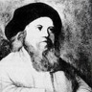
The Kotzker Rebbe
Chanuka was approaching and the next day they would kindle the first light of Chanuka. As they did every year, the Chasidim traveled to their Rebbe (Rabbi Menachem Mendel Morgensztern, zt”l, 1788-1859) to celebrate the holiday in a special atmosphere of holiness. Dawn broke and the Chasidim were still going strong, as though they had slept through the night.
"Chasidim," called out one of the elders of the group. "The sun is rising; let us go to the Rebbe." They quickly got ready for the morning prayers which were recited in an especially joyous atmosphere. After that, they set out on the way with song and dance. "G-d willing, we will arrive by this evening when the Rebbe lights the menora," rejoiced one of the Chasidim.
The wind howled. The Chasidim wrapped their coats even more tightly and continued battling the strong wind. Just a few hours remained until they would reach the Rebbe's holy court. But the sky darkened, the wind picked up strength, and snow began to fall, making walking difficult.
"Chasidim, be strong, surely this is the Satan who wants to delay us from being with the Rebbe on Chanuka. Let us muster our strength and with G-d's help we will get there safely," called out Hershel encouragingly.
They continued walking but for some reason, the road did not come to an end. According to their calculations, they should have arrived at the Rebbe's court already. A thick forest surrounded them and the Chasidim realized they were lost.
Suddenly, they heard someone shout, "Halt!"The Chasidim froze in their places. A few moments later, a band of Cossacks on horseback surrounded them.
"Ha," the evil ones chortled. "We have caught fat fish this time. Jews!" The Cossacks felt around in the Chasidim's pockets and knapsacks and took every penny they could find. They then brought them deeper into the forest to a place only the Cossacks knew about.
The Chasidim walked quietly, each one immersed in his thoughts, making a spiritual accounting, and praying for a Chanuka miracle.
The Chasidim were soon led to dark underground cells. "We will wait here until the commander comes and decides what to do with you," said a Cossacks as he whipped one of the Chasidim. Some time went by and the commander appeared. He declared that they be hung. The Chasidim began pouring out their hearts in the recital of Psalms and they rent the heavens with their tears.
At that very same time, in the court of the Rebbe, many Chasidim were waiting. The menora was ready and the first cup was filled with oil. The Chasidim waited for the Rebbe to come out of his room and light the menora.
One hour went by and then another and Reb Menachem Mendel of Kotzk was still in his room. The Chasidim there were surprised. "Every year, the Rebbe lights the menora as early as possible because the mitzva is so dear to him. Why is he waiting this year?"
The clock showed that it was close to midnight and the Chasidim were still waiting. Suddenly, the door opened and the Rebbe came out in a rush. Something looked amiss.
There was silence in the room as the Rebbe walked toward the menora. The Shamash was lit and the Rebbe said the first blessing loudly. Then the Rebbe said the next two blessings and held the Shamash to the first light, but oy, the wick did not ignite. The Rebbe tried again and again with no success. He sighed heavily and the Chasidim knew something had happened.
The Rebbe extinguished the Shamash, looked at the Chasidim, and quickly left the synagogue. The Chasidim looked at one another in shock. A commotion erupted until one of the Chasidim gave a bang and said, "It is not time for talking. Let us recite Psalms to avert the evil decree." Books of Psalms were quickly opened and the Chasidim read chapter after chapter with tears.
In the meantime, the Rebbe went to his room and changed his clothes. He put on a coarse leather jacket, big boots, a hairy coat and a leather hat that covered his face. He wrapped himself in a scarf and went out a back door into the blizzard.7
The Rebbe had a hard time walking through the deep snow, but this did not deter him from his mission. A few hours of exhausting walking passed until he reached his destination. He entered the forest and knew just where to go. He stopped at the entrance to the Cossack camp and stood there fearlessly. The Rebbe gazed at the Cossacks and they trembled. They quickly dropped their weapons and fled.
The Rebbe approached the hidden trapdoor, lifted it, and went down until he was facing the Chasidim.
"Rebbe!" they exclaimed in disbelief. "What is the Rebbe doing here? How did the Rebbe know we were in trouble?"
The Rebbe did not reply. He just motioned to them to get out and go with him to his synagogue so they could light the menora before daylight. "You did not wander far, the road to Kotzk is not long," the Rebbe said reassuringly. This time, the walk was easier and within a short time they were at the Rebbe's warm, inviting synagogue.
The Rebbe went over to the menora and lit the Shamash. This time, the first light lit immediately.

Reprinted from the Parshas Mikeitz 5777 edition of “L’Chaim Weekly,” a publication of the Lubavitch Youth Oganization in Brooklyn, NY.

Chanukah Gems

Which Menorah Should
The Father Light?

On Chanukah we celebrate by lighting the Menorah, which puts emphasis on publicizing the miracle that occurred with the oil. A question was once posed to Rav Yitzchak Zilberstein, Shlit”a.
A man told him that he had in his possession an old and ornate Chanukah Menorah made of silver. It was an inheritance that had been passed down in his family for generations. It was a work of art, and its value was many thousands of dollars. It was always an inspiration for him to light it each year, and it was also a beautiful sight to behold.
This particular year, just prior to Chanukah, the man’s young son had come home from school with a prize he had won for Hasmadah, diligence in learning Torah— it was a small brass Menorah, and the son was very proud that he had earned it.
What should the father do? Should he continue using the beautiful Menorah, or, as a sign of encouragement to his son, should he use the small brass Menorah he had come home with?
At first thought, Rav Zilberstein reasoned that since Chanukah is a time in which it is important to emphasize Hiddur Mitzvah, beautifying the Mitzvah, the father should use the silver Menorah.
On the other hand, what greater symbol of Pirsumei Nisa, publicizing the miracle, can there be than using the prize his child had won, a Menorah earned for Hasmadah in Torah study? In today’s times especially, a child who gives up his time to devote himself to Torah study perfectly demonstrates our true victory over the Greeks, who tried to get us to stop learning Torah and destroy our relationship with Hashem. This was why we fought the Greeks, and this is why we won the battle.
Rav Zilberstein told the man that we have a responsibility to publicize this fact, and he advised him to light the small Menorah that his son brought home!

Reprinted from the Chanukah 5777 email of Torah U’Tefilah: A Collection of Inspiring Stories compiled by Rabbi Yehuda Winzelberg.
The President’s
Last Chanukah Reception

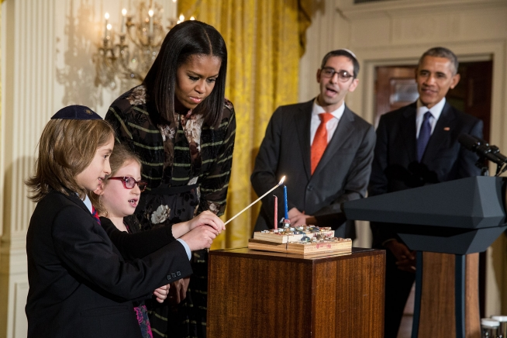
President Barack Obama, First Lady Michelle Obama and Rabbi Steven Exler watch Elijah and Shira Wiesel [grandchildren of the late Elie Wiesel] light the menorah during a Hanukkah reception in the East Room of the White House, Dec. 14, 2016. (Official White House Photo by Chuck Kennedy)

President Obama hosted his final Chanukah White House celebration, joined by community members from across the United States.
As the secular holidays coincide with the beginning of Chanukah, a time when the president is on vacation in Hawaii, the traditional White House receptions were moved up by over a week to accommodate the president’s schedule. As the president joked, “It so happens we’re a little early this year. But Michelle and I are going to be in Hawaii when Hanukkah begins, and we agreed that it’s never too soon to enjoy some latkes and jelly doughnuts.”
Following what has become a tradition in the Obama White House, there are two receptions, one in the afternoon and one in the evening, to allow for a diverse array of Jewish personalities from across the spectrum to participate. The president jokingly alluded to this in his evening remarks. “This is our second Hanukkah party today, but in the spirit of the holiday, the White House kitchen has not run out of oil.”
At the afternoon ceremony, the Obamas honored Elie Wiesel, the Holocaust survivor, author, and Nobel Peace Prize winner who passed away earlier this year.
“It’s important for our community to internalize that the White House Chanukah Reception is not merely a party to socialize but an important milestone for the Jewish community when the leader of the free world identifies with the historical aspirations of our people,” said Ezra Friedlander, CEO of The Friedlander Group. “When the president speaks, the world listens, and this year’s remarks addressing issues pertaining to highlighting the protection of religious freedom was especially significant in light of recent attempts to ban religious rituals domestically and abroad.”
President Obama’s remarks addressed this topic:
“The first chapter of the Hanukkah story was written 22 centuries ago, when rulers banned religious rituals and persecuted Jews who dared to observe their faith. Which is why today we are asked not only to light the menorah, but to proudly display it—to publicize the mitzvah.
“Everybody in America can understand the spirit of this tradition. Proudly practicing our religion, whatever it might be—and defending the rights of others to do the same—that’s our common creed. That’s what families from coast to coast confirm when they place their menorah in the window—not to share the candles’ glow with just your family, but also with your community and with your neighbors.”
The president concluded by honoring the memory of Elie Wiesel: “The story of Hanukkah, the story of the Jewish people, the story of perseverance—these are one and the same. Elie Wiesel taught us that lesson probably better than just about anybody. In one of his memories of the Holocaust, Elie watched a fellow prisoner trade his daily ration of bread for some simple materials with which to piece together a makeshift menorah. And he wrote that he couldn’t believe the sacrifices this man was making to observe the holidays. A stunned Elie asked him, ‘Hanukkah in Auschwitz?’ And the man replied, ‘Especially in Auschwitz.’”

Excerpted from the December 23, 2016 edition of the 5 Towns Jewish Times.

Shabbos Stories for
Chanukah festival 5778
Volume 9, Issue ??? 25 Kislev 5778/ December 13-20, 2017
Printed L’illuy nishmas Nechama bas R’ Noach, a”h

For a free subscription, please forward your request to keren18@juno.com

Story #995
A Deserved
Chanukah Miracle
From the desk of Yerachmiel Tilles
editor@ascentofsafed.com

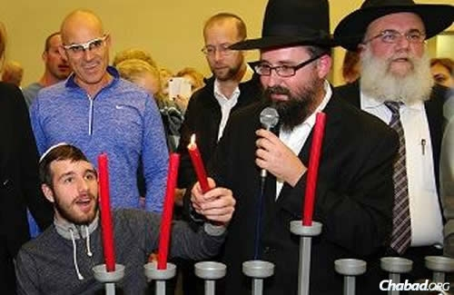

The first time Rabbi Menachem Kutner and Rabbi Yossi Swerdlov of the Chabad Terror Victims Project met Sgt. Ohad Benyishai of the Israel Defense Forces, he was lying unconscious in a hospital bed. He had been critically injured in mid-July of 2014 during "Operation Protective Edge" in Gaza, where he was deployed with his Golani Brigade's elite Egoz commando unit.
He and his unit's comrades were involved in a brutal battle in Gaza's Shuja'iyya neighborhood, which later became known as the bloodiest battle with Hamas during the entire operation. Thirteen soldiers lost their lives during the battle and many were injured. Ohad suffered a serious shrapnel wound of his head and was identified as the most seriously injured soldier during the operation.
He was quickly airlifted to the Soroka Medical Center, where on his arrival, his condition was so serious that the hospital doctors did not think he would make it through the night, but they refused to give up. After an unrelenting battle to stabilize Ohad that lasted a few weeks, Ohad rewarded their efforts when he regained consciousness.
In the months that followed, Benyishai slowly, with great determination and effort, and with devoted family support, began relearning how to function. He also mastered the Hebrew alphabet, and had even managed to say two words, ima (mom) and abba (dad), but no more.
On the second night of Chanukah, the rabbis visited the Sheba Medical Center in Ramat Gan, where he was recovering and had just celebrated his 20th birthday. There, around 70 wounded soldiers, their families and Chabad volunteers gathered for a special celebration and menorah-lighting.
Benyishai was invited to light the menorah together with Kutner. The rabbi said the blessings, and Benyishai held the shamash (helper candle) with his functional left hand. With the rabbi's assistance, he lit the two candles.
Then suddenly, the room went quiet as Benyishai slowly began to mouth the words to "Haneirot Halalu" and "Maoz Tzur" along with Kutner. The familiar traditional Chanukah tunes that he had learned during his childhood had brought back his ability to speak. He was talking!
His parents ran to him, and showered him with hugs and kisses with tears streaming down their cheeks. They had their Chanukah miracle.
Ohad was released from Sheba Hospital after an 18-month long recovery period on Monday, February 8, 2016, and returned home, but he will need to continue to undergo rehabilitation procedures in order to regain his full capacity.
Please continue to pray for the ongoing recovery of Ohad ben Erica, and the brave men and women of the IDF who have sacrificed so much to protect our precious homeland.
Source: Adapted and supplemented by Yerachmiel Tilles from an article on //Chabad.org. (The 2nd paragraph is adapted from //IsraelToday.co.il; the 2nd-to-last paragraph is from //IsraelNationalNews.com (Arutz Sheva). The photo is also from Chabad.org.)
Connection: Seasonal: Chanukah miracle.

Reprinted from the December 26, 2016 email of KabbalaOnline.org, a project of Ascent of Safed. www.ascentofsafed.com ascent@ascentofsafed.com

Chanukah: If You're Assimilated, It's a
Season of Confusion
By Miriam Karp/AMI

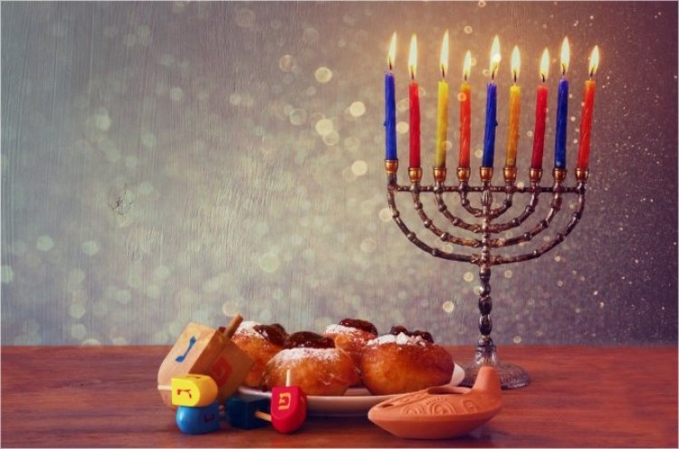

December is the season of utter confusion for a Jewish kid from an assimilated family wading through the American melting pot. Unless you have a very clear, strong Jewish identity, you feel the tension. What do you answer the cashier who extends a certain holiday greeting? What about the school play and the company party? It’s the time of year for clarification.
As the month progresses, the mall parking lots fill up, and the green and red decorations become ubiquitous, the unaffiliated Jew is pushed to reexamine and redefine the “Jewish thing.” Where does he draw the line and assert his differentness? Such questions are usually lost in the anesthetizing din of the media and the pressures of daily life. But come December, they’re hard to ignore. Growing up in the suburbs during the 1960s, I was torn. A second-generation American, my childhood was saturated with Yiddish culture, Bubby’s knishes, Jewish jokes and Fiddler on the Roof, but little in the way of real Jewish beliefs or day-to-day practice. I was jealous of my non-Jewish friends’ tree, candy canes and mountains of presents. I wanted to fit in. Badly.
Our little menorah and greasy latkes couldn’t compete with all that glitz. So I did sit on you-know -who’s lap, especially since our family friend Rube Weiss was the most famous one in town. I begged my parents for a Chanukah bush, but they weren’t willing to go that far.
Then one year Grandma Ida said yes! Grandma had been raised in an Orthodox home. On her wall, her parents looked out sternly from a turn-of-the-century photo, her father clad in a long black coat and hat, her mother peering out from under a boxy sheitel. Unfortunately, uneducated in Jewish matters and married to a socialist, Grandma kept her superstitions to herself.
We modern, rational Jews had no need for “kenahoras” and all that nonsense. Keeping kosher was a quaint relic of ancient times; nowadays we had sanitation and refrigeration. Grandma Ida sighed and accepted the new order. She smiled and bought us a Chanukah bush and stockings for the fireplace, and in the spring she bought us marshmallow bunnies and chocolate chick baskets. Why should her grandchildren be deprived?
I wish I’d learned something authentically Jewish from someone who was knowledgeable when I was young and far adrift. Maybe it would have saved me from roaming so many dead-end streets in my search for something deeper. Baruch Hashem, after light-years of searching, intensive change and discovery, I knew exactly what to do in December: get out that menorah, start frying latkes, invite the neighbors—the works.
Chanukah was celebrated with all of its genuine warmth, light and holiness; the kids were suffused with joy and excitement. I knew they were in quite a different place than I had been at their age when we happened to drive past a display of lights one year.
“Close your eyes!” my son Mendy, the little zealot, yelled to his siblings. “It’s avodah zarah!”Indeed, December is the season of sadness and confusion for so many well-meaning Jews. For several years I taught in a Reform Hebrew school. I was able to make my own curriculum and viewed the job as outreach.
Every year before Chanukah we’d have a discussion about what we were doing for the holidays. It was usually the smartest, most Jewish-looking kid in the class who would inevitably tell me, “We’re spending Chanukah with one grandmother and the other holiday with the other grandmother.”
“Oh,” I’d say with a sinking heart. “Which grandparents are Jewish?” David Cohen or Sarah Friedman or Josh Rubinstein, another nice kid, would invariably reply, “My dad’s parents.”
We are taught that only a small fraction of the Jews who were enslaved went out of Mitzrayim. I am often amazed and bewildered; how on earth did I start out way over there, wondering why my parents kept making that ridiculous racist demand that I marry a Jew—and end up all the way over here? How did I manage to jump over that vast cultural divide?
I don’t know; it must be zechus avos. How did I give up my university-conditioned cynicism? How did I accept covering my hair, so much cooking, cleaning for Pesach, kapparos—all the myriad details?
As I look back over my shoulder at those who are still on that distant multicultural shore, I realize how difficult it is for them to relate to all the stuff we do over here. They don’t even have the language to ask the right questions, to know how hungry they are.
Finding a way to show them how beautiful it is seems daunting. Some people might say, “It’s over. You can’t worry about them. Don’t look back; just hang on tight and build new generations. It’s sad, but that’s how it is. They’re gone.”
I don’t like that. It hurts. It’s wrong. I know how sweet and good those confused, earnest, assimilated and seemingly lost neshamos really are. I’d much rather sing “No Jew Will Be Left Behind” with Avraham Fried. But such a vision seems impossible. My father recently met his best friend from kindergarten, a friendship that has lasted over 80 years.
This dear man and his wife just moved into a non-Jewish assisted-living facility, complete with poinsettias and figurines and all of the other December trappings. Having long ago made peace with his intermarried sons and non-Jewish daughters-in-law and grandchildren, he is no longer bothered by the lack of kosher food or other Jewish staples. My heart aches thinking of them spending their twilight years in such a place.
Bridging the gap seems impossible. Like Chanukah. Like Eretz Yisrael. Like the Jewish people. How does such a ragtag band of persecuted wanderers continue to exist? How did the few beat the many? How did one tiny cruse of oil last eight days? How did I make that transition to the world of Torah, becoming the matriarch of a tribe of children and grandchildren with proud Jewish names and identities, bli ayin hara, whose lichtige pictures grace my dining room wall? Visitors gaze. It’s not an earthly thing. It’s not even logical to have raised all those kids, paid tuition, and bought shmurah matzah on a chinuch salary. It doesn’t make any sense at all. It’s a heavenly thing, like Chanukah, like the pintele Yid, the pilot light of the soul that continues to burn in even the most distant, most assimilated Jew.
Nowadays I travel a lot to speaking engagements. Invariably, in every audience, she is there—the one I was meant to meet. We recognize each other. A psychiatrist. An artist. A mom. A grandma. These neshamelach come in many forms and span the spectrum of socioeconomic and educational back grounds.
All their status and busyness just didn’t satisfy them. They’re all hungry neshamos, alive, the flame reaching upward, almost jumping off the wick with excitement. They’ve finally found a name for the driving force that’s been making them crazy all these years. They’ve found out where to get their neshamos some wholesome food.
I’m usually more inspired than they are. I’m revived. It’s really true—the Jewish neshamah cannot be extinguished. Each one has its own journey, its moment, when the dormant cinders blaze anew. And Hashem will lead each one lovingly home. Each one.
Take that, Pew Report, with your grim statistics! Where do we light the menorah? In the window, in the doorway. We’ve got to let that delicious light shine out into the darkness, burning until each soul is brought in from a cold, dark, empty street.
Inside. Around a warm table. And our light— Hashem’s light—is enough, enough to outshine the tinsel and the thousand million shtussim (foolish things) out there. And though it’s sometimes hard to see just how it will happen, it’s enough to bring them all home.

Reprinted from the Chanukah website of Hidabroot.

L’Maaseh

The Broken Flask

Rav Shabsi Yudelevitz, zt”l, one of the famous Magiddim of Yerushalayim, relates a beautiful and inspirational story. A poor Rabbi, who over a hundred years ago, had to go to Milan, Italy, to collect money for his family. When he got off the boat he met a wealthy, Jewish man, and he invited the Rabbi to spend Shabbos with him.
At the Seudah that night in the wealthy man’s mansion, the Rabbi saw a beautiful closet filled with exquisite silverware and crystal. He also saw something that seemed to be out of place amongst the luxurious items— a broken glass flask, with sharp points of jagged glass jutting out.
The wealthy man noticed the Rabbi’s look and asked him if everything was all right.
The Rabbi asked about the broken flask, and the wealthy man was more than happy to tell him the story.
The man was born in Amsterdam and came to Italy when he was eighteen years old, to help his grandfather run the family business. Eventually, his grandfather passed away, and his parents wanted him to sell the business and return to Amsterdam. The man, however, was very successful in the business and decided to remain in Italy, where the business kept him very busy.
One day, he was so involved with work that he forgot to Daven Minchah. A few days later he got busy early in the morning and he realized that he had forgotten to Daven Shacharis, and one by one, he stopped doing Mitzvos. Eventually he got married and had children, but he was leading a secular life. He remembered that he was Jewish, but he barely practiced any of the Mitzvos.
One afternoon he was taking a walk and saw some children playing. They all seemed to be very happy, but then he heard one of them start screaming and crying, and he kept saying, “What will I tell my father? What will I tell my father?” No one could console him.
The wealthy man went to see what the problem was. He found out that the boy came from a poor family and that his father had saved a few precious coins throughout the winter to buy a flask of oil for Chanukah, and sent this boy to buy it. His father warned him to come straight home with it and not to stop and play with his friends, as the flask may break. The boy didn’t listen, though, and sure enough, while he was playing, the flask broke and the oil spilled out.
The man asked the boy to come back to the store with him, and he would buy new oil for him to bring home. The man bought a larger flask of oil than the boy had originally gotten, and sent the now happy boy straight home with the precious oil, as well as some money for his family.
As the wealthy man was walking home that evening, the little boy’s words rang in his ears. “What will I tell my father? What will I tell my father?” And then he thought to himself, indeed, what will I tell my Father? My Father in Shamayim, Hashem, after my time here on this world? He had drifted so far from Yiddishkeit that he had forgotten that is was almost the first night of Chanukah! What excuse would he have when he stood before his Father in Heaven on that final Judgement Day?
The man walked back to where the children were playing and picked up the broken pieces of glass from the flask and took it home with him. That night, to the surprise of his wife and children, he lit a Chanukah candle. The next night, he lit two, and with each passing night, he increased the amount of candles for eight nights. He stared at the candles as they flickered and sparkled, and he remembered his parent’s home back in Amsterdam. He had realized that he had gone too far away.
The wealthy man concluded his story, “That Chanukah was the beginning of my return to the observance of Mitzvos. Eventually, with the understanding and help of my wife, we began training our children the way we were brought up. Our road back had started with that broken flask and the words of that boy, ‘What will I tell my father?’ And that is why I keep the broken pieces of that flask, as a treasured reminder of what changed my life!”

Reprinted from the Chanukah 5777 email of Torah U’Tefilah: A Collection of Inspirational Thoughts compiled by Rabbi Yehuda Winzelberg.

Behind World's
Largest Menorah
By Moshe Ben Chaim

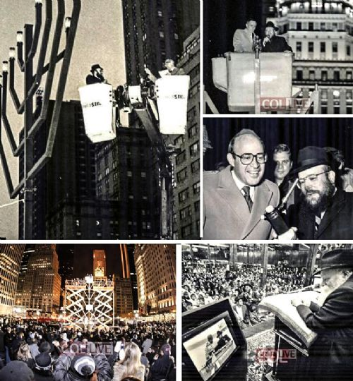
How did the world's largest Menorah end up on Fifth Avenue and how did Mayor Ed Koch shut down Chabad's critics.

As we store away our Menorahs until next Chanukah, we wanted to focus the emphasis on one of the most unique public lightings -- on Fifth Avenue in Manhattan.
There, as every year, proudly stands a gigantic Menorah, the largest in the world, according to Guinness World Records, that brings a phenomenal amount of publicizing of the miracle of Chanukah, as every day hundreds of thousands of people are exposed to it.
The Kfar Chabad magazine recently revealed interesting details about how this Menorah came about, in an interview with prominent officer of the Israel Defense Ministry and the Israel Foreign Ministry Yossi Ciechanover. His wife, Mrs. Atara Ciechanover, initiated the concept of this menorah.
The Chossid who took upon himself, at the time, the expenses of the Menorah and who actually organizes all the public lightings of the Menorah is Rabbi Shmuel Butman, the director of the Lubavitch Youth Organization.
It was difficult to reach Rabbi Butman during Chanukah as he was busy with daily arrangements for the public lighting with the participation of public figures and guests.
Now that Chanukah is over, we asked to speak to him and to hear about the "behind the scenes" story and it seems that many details were not yet revealed.

How did it all start?
In the 1970's the Rebbe spoke about public Chanukah Menorahs to publicize the Miracle of Chanukah. "We wanted to do that in the best way that befits the Big City," Rabbi Butman told us in the talks that we had with him this week.
"This is how in 5738 (1977) this Menorah was built. The size of the Menorah was 30 feet. We called the Menorah the "World's Largest Menorah" and that is how it was recorded by the world media who covered extensively the lightings each day. World media used the Menorah as the symbol of Chanukah."

Who designed the Menorah? Who built it? And what was the cost?
We used a classic design. It was not yet the custom to use the Rambam design. After considerable efforts we found, with G-d's help, a company who specialized in designing and building objects of metal and steel.
The company wanted $5000 for the design and construction. Not a small sum in those days. I contacted a supporter, Mr. William Goldberg OBM, president of the Diamond Dealers Association. Mr. Goldberg was so excited with the idea that he personally came to our office and paid for the Menorah.
Although he is no longer with us, his wife comes to the Menorah each year and feels like a partner.
For nine years, this Menorah captured the attention of the world media, due to the unprecedented Pirsumei Nisso publicizing of the miracle of Chanukah. Every year the media flocked to cover the Menorah. Even the New York Times, that isn't always enthusiastic about Jewish matters, wrote about this Menorah."

When was the famous Agam Menorah built?
In 5747, Yaacov Agam designed the Menorah. A model of the Menorah in miniature stood on the Rebbe's desk for 3 days. The entire project was arranged by Mrs. Ciechanover.
According to the words of Yaacov Agam, the Rebbe wanted the Menorah to be built to the maximum height permitted by halacha, 20 Cubits, which is 32 feet. The price for constructing this Menorah was $25,000, paid by the Lubavitch Youth Organization.

And what exactly did you do with the first Menorah?
That Menorah, till this day illuminates the surroundings at "Park Circle," the gateway to Crown Heights, Boro Park and Flatbush, where tens of thousands of vehicles pass by daily."

Which directives were from the Rebbe concerning this Menorah?
Rabbi Mordechai Hodakov, the head of the Mazkirus (secretariat) of the Rebbe showed an interest in all the details. Who is lighting today? etc. According to his directives we invited the then Mayor Abraham Beame to light.
I remember that Rabbi Hodakov very much wanted that United States Senator Jacob K. Javits should light the Menorah. Javits at the time was old and in poor health. It did not seem possible that he would come. But when Rabbi Hodakov said that he wants him to light, I went to work on it. With Rabbi Hodakov one never knew 'where the directive comes from.' Thank G-d it was with success. Senator Javits came, got into the lift and lit the Menorah.
I once got a call from Rabbi Yehuda Krinsky, the Rebbe's secretary. It was the night that the eighth candle was lit. The Rebbe told him that night to call me and ask me to light the Menorah again the next morning. We do this till this very day.

These directives came straight from the Rebbe?
This is part of what it says ‘to what is beyond you don't reach.' I will give you a case in point. Rabbi Hodakov told me to invite Robert Abrams to light. He was at the time Bronx Boro President. I answered that I don't know if there are enough open nights. Rabbi Chodakov just repeated what he said, that Robert Abrams should be invited. He was invited and he came.
A few years later Robert Abrams was elected as Attorney General of the State of New York. He came every year to light the Menorah. When an individual complained to the Rebbe about the separation of Church and State the Rebbe responded that how can there a problem of Church and State when the man in charge of that in the State of New York came himself to light the Menorah. One then understood that the suggestion of Rabbi Hodakov came ‘from above.'"

One cannot help but admire the spot that the Menorah was given...
Indeed. This is a case of S'yato Dishmayo, (heavenly intervention). Within the laws of nature, we had a good relationship with Mayor Abe Beame and he gave the order. The permit officially was issued by the Parks Department but the permission came from the Mayor's office."

Many stories have accompanied the Menorah. Can you share one of them with us?
Every New York Mayor lit the Menorah, including Ed Koch. Ed Koch was once invited to St. Louis as the Guest Speaker for the United Jewish Appeal. After his formal speech, a woman who was at the time the head of the opposition to the lightings of public Menorahs [in St. Louis], asked him for his opinion. She was certain that he would oppose it. Ed Koch answered in his characteristic blunt manner: "In my city, we have the largest Menorah - and I myself lit it." Supporters of the public lightings applauded at length and the Menorah [in St. Louis] went up.

In conclusion, Rabbi Butman, what is your message?
That the lights that all Jews and the Rebbe's Shluchim light, the world over, should usher in the eternal light of the great redemption imminently.

Reprinted from the January 5, 2017 website of COLLIVE.com
What You Should Know About “Sufganiot”
Jelly Doughnuts
By Leon Samuels

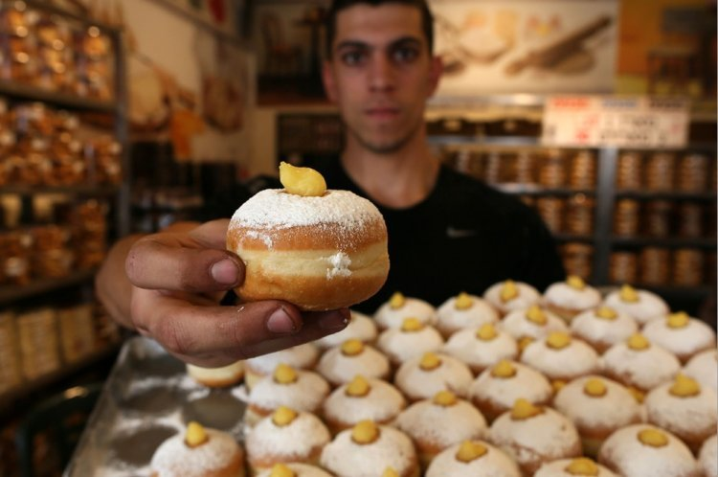

Why Kashrut Supervision is Important
When You Buy a Sufgania.

Chanukah is around the corner. One of the Chanukah customs is to eat foods fried in oil to remind us of the miracle of oil. Jelly doughnuts rate high on the Chanukah menu along with potato latkes. In Israel most of us already had a sneak preview tasting of the jelly doughnuts (which could be filled with caramel, custard or other fillings other than jelly).Rabbi Pinchas Adiria, Supervisor of the Kashrut Division of the Israel Rabbinate, want people to know what to look in Kashrut for when buying these doughnuts. This first part is general advice but more applicable to Kashrut supervisors or those making the doughnuts at home.
1) Make sure the deep fryers were kashered making sure they are not meaty and have not absorbed non-kosher substances.
2) A Jew must turn on or light up the deep fryers.
3) If the dough is large, 2 kg. or more of flour, Challah must be separated before using dough.
4) Make sure flour was properly sifted to remove small bugs common in flour.
5) When using a dairy filling like caramel some filling should be obviously visible on top so people will know it is dairy and not accidently eat it with a meaty meal. A merchant must place a “dairy” sign next to these doughnuts.
6) Merchants must have separate areas for dairy doughnuts and parave doughnuts. They should also refrain from making dairy dough so as not to get confused and make a parave doughnut with this dough.
7) Packaged doughnuts should be appropriately labeled “Parave” or “Dairy”.
For doughnut buyers:
Make sure the bakery has proper kashrut supervision from the local Rabbinical Council. This prevents kashrut fraud. Because of all the aforementioned requirements proper Rabbinical supervision is imperative.
Enjoy your kosher jelly doughnuts and have a great Chanukah!

Reprinted from the December 20, 2016 website of Hidabroot.
Chanukah at Valley Forge, 1777
From the desk of Yerachmiel Tilles

It was December 1777, when the American forces under General George Washington were awaiting the famous battle at Valley Forge. The future president was deeply concerned about the welfare of his troops. The bitter cold and the poor provisions with which his soldiers of the revolutionary army had been provided did not bode well for the outcome of the critical battle that awaited them.
Wrapped in his officer's cape and clapping his three-cornered hat down hard on his head against the chilling wind, Washington went out to see at firsthand how his men were faring. As he went from tent to tent, he saw the men dressed in rags and huddling around small fires, trying to get together a meal of something hot. As he went on, he suddenly encountered a single soldier, bent over a small metal apparatus in which he had lit a few very small, tallow candles.
Intrigued, Washington asked him what he was doing. Startled, the man jumped to his feet and saluted. Just at that moment, he had little expected to find his commander so near. But again Washington repeated his request: to understand why he had lit those little candles here, in the middle of nowhere.
The soldier, who of course was Jewish, began to unfold the age-old tale: of foreign Greeks who, upon conquering the holy land of Israel, had entered the Temple and had placed their idols in the most sacred place of worship. And he told how the valiant Maccabees, no longer able to bear the evil degrees forbidding the performance of Jewish ritual and the learning of Torah, rose up against their lords even though they greatly outnumbered them and were better armed - "Just like here, only more so, he interspersed."
Nevertheless, through the grace of Heaven, they succeeded in removing them from their land. And last of all, the soldier explained how they purified the sanctuary and, finding only one container of oil which remained undefiled, they used it to light the Menorah. Yet miraculously that one container of oil, which should have been enough for only one day, instead lasted for eight -- until new oil could be made. And this, he told the general, is why he was lighting those little lights.
General Washington stood enthralled. He looked at the little flames, and at the face of the Jew. Then, he laid a firm hand on the man's shoulder. "You are a Jew," he exclaimed," "from the nation of prophets! I treat what you just said as a message from the Al-mighty Himself! With your little lights and your inspiring story, you have struck new courage in my troubled heart."
The General shook the young soldier's hand, saluted, then turned to continue on his rounds. What happened the next day is history: Washington's forces scored a victory over the British, and this proved to be the beginning of their total success. Eventually it led to the independence of the United States of America from England.
But what is less known is the following. That Jewish soldier survived the war and returned to his home in Boston. [another version: New York City, on Broome Street -ed.] One evening, some few years later, he was sitting with his family around the dinner table when there was a knock at the door. He was astonished to see two very official-looking men standing there, but after a moment he recovered his poise and invited them in.
After introductions, one of the men stepped forward and took out a small box covered in velvet, from his inside coat pocket. With a cheerful smile, he handed it to the Jewish host, saying, "Here, take this. It is for you."
The veteran soldier looked from one face to the other for some sign of what was going on. Slowly he opened the box. It was plushly lined, setting off a brilliant gold medallion. On it was engraved a picture of a Menorah with the words inscribed: "With admiration, from George Washington."
One of the visitors then handed him a letter from the first president himself. "This will explain everything," he said. "My dear friend," was the salutation. "You don't know what you accomplished that night at Valley Forge. I couldn't sleep that night because I was sure that we had no chance of winning. We lacked ammunition. We were outnumbered ten to one. We didn't even have food or bedding for the soldiers. When I saw those boys lying asleep in the freezing cold under those thin blankets it took away my resolve. I made up my mind then and there… to surrender.
“But your lights and your words changed all that. If it wasn't for you and your Menorah, I don't know if we would be standing here today as free men. So we decided to present this medallion to you as a testimonial to that night, which was a turning point in our struggle for freedom."
Adapted by Yerachmiel Tilles from several Jewish and non-Jewish sources on the World Wide Web. Yerachmiel Tilles is the director of the AscentOfSafed.com and KabbalaOnline.org websites. His mailing list of 900+ weekly stories (editor@ascentofsafed.com) is now in its 20th year. “Festivals of the Full Moon,” the second of a 3- volume series of his best stories, is now available in Tzefat at Ascent and KabbalaOnline-shop.com.

Reprinted from the Parashat Mikeitz 5777 email of Jewish Living from Chabad of the Cardo [in Yerushalayim.]
It’s Always Hanukkah in This Picture-Perfect Italian Town
By Ruth Ellen Gruber

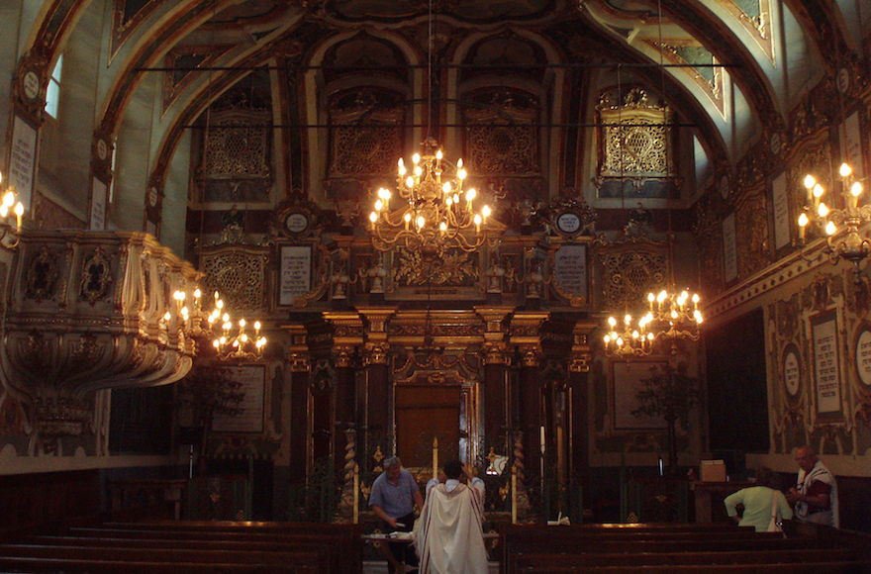
An inside view of the synagogue in Casale Monferrato, Italy, which dates to the 16th century. (Wikimedia Commons)

CASALE MONFERRATO, Italy (JTA) – It’s always Hanukkah in this picturesque town in northern Italy’s Piedmont region.
Jews have lived in Casale Monferrato for more than 500 years, with the community reaching its peak of 850 members at about the time Jews here were granted civil rights in 1848. The town still boasts one of Italy’s most ornate synagogues, a rococo gem that dates to the 16th century.
These days, only two Jewish families live in Casale. The synagogue, which is part of a larger museum complex, is now a major tourist attraction – and not only because of its opulent sanctuary with huge chandeliers, colorfully painted walls and lots of gilding. The former women’s section has been transformed into a Judaica and Jewish history museum. And the synagogue’s basement, formerly a matzah bakery, is now home to the Museum of Lights.
Hanukkah here is commemorated nonstop with a year-round exhibit featuring dozens of menorahs, or hanukkiyot, created by international contemporary artists. The collection has some 185 menorahs, according to Adriana Ottolenghi, whose husband, Giorgio, has been president of Casale’s Jewish community since the 1950s. There is no other museum in the world quite like it.
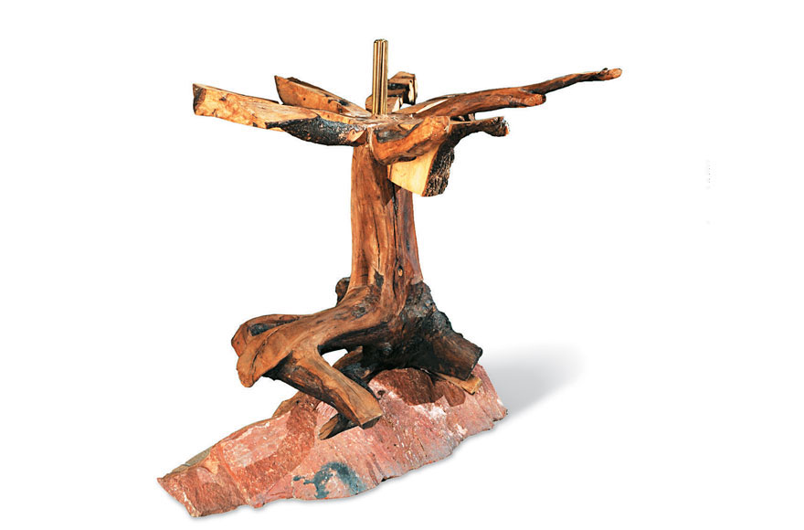
This is one of the nearly 200 menorahs at the Museum of Lights in Casale Monferrato (Foundation for Jewish Art, History, and Culture at Casale Monferrato and in Eastern Piedmont – Onlus)
“We receive more every year, and each year at Hanukkah there is a public ceremony, where we light menorahs and welcome the new pieces,” she said.
Only 30 to 40 can be displayed at a time in the vaulted underground chambers. The only time the collection was shown in its entirety was at Casale’s centuries-old castle, part of an event connected to the 2015 Milan Expo.
The Museum of Lights’ hanukkiyot come in an amazing variety of shapes, sizes, colors and media. Many resemble traditional menorahs: a straight line of candles or a candelabra with eight branches, with a ninth branch for the “shamash” candle used to kindle them. Some of the menorahs can be lighted and used on the holiday.
But other menorahs on display are more fanciful sculptural works created from the likes of metal, ceramic, plexiglass and wood.
“Artists were given a completely free rein to create a functional object or a purely evocative one,” curator Maria Luisa Caffarelli wrote in the collection’s catalog.
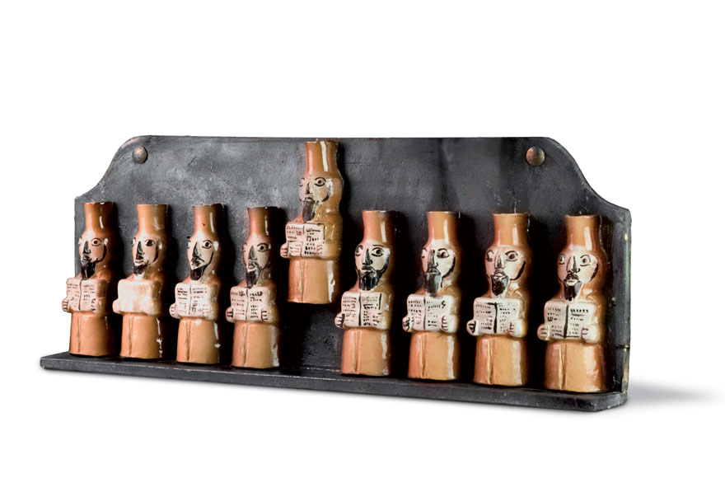
This menorah is part of the year-round display at the Museum of Lights. (Foundation for Jewish Art, History, and Culture at Casale Monferrato and in Eastern Piedmont – Onlus)

Each menorah is what designer Elio Carmi, who co-founded the collection in the mid-1990s with the non-Jewish artist Antonio Recalcati and other artist friends, describes as an “homage to the story of Hanukkah” and its message of the triumph of light over darkness.
They conceived the project as a way to highlight Jewish culture as a source of artistic inspiration, promote creativity based in Jewish tradition and underscore the vitality of Jews in contemporary society.
“The idea was born to show that Jews, though small in number, are determined,” said Carmi, who is the vice president of the Casale Jewish community, “and to use interpretations of the Hanukkah menorah to demonstrate, symbolically, the continuity of the community.”
At Hanukkah, Jews light menorahs for eight days to recall the defeat by the Maccabees of Syrian tyrants in the second century BCE. According to legend, when the Maccabees reclaimed the Temple, the eternal light miraculously burned for eight days rather than the expected one, symbolizing the survival of the Jewish people.
Each menorah in the museum is a personal interpretation of the Festival of Lights and its symbolism. The Italian artist Stefano Della Porta, for example, used ceramics and steel to create a menorah that appears to be made from giant burnt matches. American-born artist Robert Carroll created his menorah from olive wood, red Verona granite and brass. It has a sinuous, trunk-like base that supports eight branches that open out like a flower, each supporting a candle.
Carmi and his friends provided the first hanukkiyot for the project — Carmi’s was a silver-plated metal bar with small cups for the eight candles and the shamash — and then reached out to others for contributions.
Other artists — Jews and non-Jews, mainly from Italy but also from other countries — soon began making their own menorahs and presenting them to the growing collection. All of the works are donated, most of them by the artists themselves.
“It was like a chain of artists,” Carmi said. “And well-known artists began to be attracted.”
Among those is Arnaldo Pomodoro, one of Italy’s leading sculptors. His menorah, presented in 2013, is a horizontal metal girder that supports the nine candles and is decorated with abstract symbols.
“I tried to bring out a series of abstract, imaginary signs to create a story that would connect, on a general level, with the idea of thought, experience and memory; without, however, wanting to enter into the multi-faceted complexities of the symbology of the Jewish world,” Pomodoro describes in the catalog.
Ultimately, Carmi said, the Museum of Lights is about “Judaism, art and identity.”

Reprinted from the November 15, 2017 website of the JTA (Jewish Telegraphic Agency)
News Brief
Canada Issues First
Hanukkah Postage Stamp
November 21, 2017
MONTREAL (JTA) — Canada issued its first Hanukkah stamp in its official mail carrier’s 150-year-history.
Described as part of an initiative to highlight the nation’s cultural diversity, the stamps from Canada Post feature two colorful geometric designs: of dreidels and the menorah. Each pattern also has an online explanation of their relevance to the holiday.
They are arriving three weeks before the first candle is lit.
“In offering the great products, Canada Post is enabling our community to share the beauty and inspiration of Hanukkah with all Canadians,” said Shimon Fogel, CEO of the Centre for Israel and Jewish Affairs.
Canada Post made an initial issue of 3 million Hanukkah stamps and has indicated that if trial-run sales go well, it will make more over the next few years and eventually add new designs.
As part of the diversity initiative, Canada Post also issued stamps for the Muslim festival of Eid and the Hindu holiday of Dawali. Since 1964 and until this year, it had issued only Christmas stamps.
(Editor’s Note: The first Canadian Hanukkah stamp was designed by Angela Brown Carter of Entro Communications, that has offices in Toronto and Calagary as well as in Switzerland.

What One Menorah
Lighting Can Do
By Chana Sara Einseiger

There was always something about lighting a menorah. Even when I was in foster homes as an adolescent, it was something I wanted to do. Maybe it was knowing that my ancestors did the exact same thing, or that millions of people all over the world were staring at the candles too. Or maybe it was just that candlelight is so warming when the ground outside is covered in snow. I’m not sure, but I certainly never expected that lighting a menorah would have any impact on my day-to-day existence.
Nearly three years ago I decided to drop Judaism entirely. I was fed up with the entire venture. The temple I attended was costly and uninviting, not at all what I had expected. There would be no community to raise my daughter with, no traditions to pass on to her. Needless I decided to drop Judaism entirelyto say, I was a little bitter about the whole thing.
But, of course, every year I lit a menorah. When my daughter was old enough to appreciate it, I decorated the house with Chanukah flags and garlands, window stickers and crafts. Maybe at some point in her life she too would enjoy the feeling of comfort and safety that I got from the flickering candles.
The temple with which I dropped membership proceedings still sent me a newsletter occasionally, and that year I saw that various synagogues were holding public menorah lightings around the county. A giant menorah! Perfect! I dressed up my little girl in a pretty blue dress and built her anticipation to see a menorah as tall as a tree.

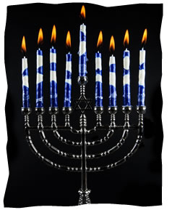

It turned out to be less dramatic than I had hoped—just a few people had gathered to see the lighting. Some homeless men were milling around. There was talk of free latkes and hot drinks in a nearby building afterwards, but as soon as the lighting was over I scooped up my daughter and made a dash for the car. My exoduswas interrupted the rabbi. He introduced himself and gave my daughter a little menorah necklace.
“Do you belong to a synagogue?” he asked.
“No,” I replied. The memory of the other temples I had been to, their high fees and constant focus on what my occupation is, rather than who my daughter and I are, made me suspicious of this rabbi. Does this one want twice the cost of my medical insurance for my daughter to play around his children?
The rabbi told me the address of his synagogue. I narrowed my eyes. ”And how much does it cost?”
His face lit up. “This is why I do this,” he said. He told me there were no membership fees. I was astounded.
So I went to the local Chabad Lubavitch. Yes, it was awkward. There was a definite language barrier, and I often had trouble following the service. But the people were friendly, and I didn’t have to sign There were no membership fees. I was astoundeda contract to be there. So I went back again, even though going to a Chabad synagogue if you weren’t raised in the world of Judaism is like diving before you learn to swim.
After some coaxing, the rabbi’s wife, Devorah, convinced me to sign up my daughter for Sunday Hebrew school. On the first day, they were having a shofar factory. The smell of power drills running into animal bones and shellac was awful, but my daughter loved it. She looked around wide-eyed at the other kids, made a friend, and was fascinated with the shofar she shellacked. I was sold.
On my way out, the rabbi said to me, “Look what one menorah lighting can do.” I smiled, but didn’t think much of it.
Time has gone by, and now I can’t forget the rabbi’s words. Yes, when I attend a service I still prefer to hide in the kids’ room, where I have some idea what I’m doing (mostly staring at the fish tank), and most of my agnostic-style views haven’t changed, but plenty has. My daughter finished a year in Hebrew school and is learning a new language. She is so proud of all her projects, and so happy with the friends she has made.
Because she enjoyed Hebrew school so much, I enrolled her in the Chabad preschool. She loves her teachers, and I’m glad that she’s in such capable hands. She has developed socially and gained a bit more confidence. After more coaxing from Devorah, she even attended summer camp. So much has changed in our routine, changes that will be there for years to come. She is making memories that she can treasure for life. That is what one menorah lighting can do.

Chana Sara lives in Whitehall, Pennsylvania, with her husband, daughter, and too many pets. She is the office manager at Chabad of the Lehigh Valley where she helps produce the Wellsprings Magazine which is published 5 times a year. What she enjoys most about working at a Chabad House is having the constant opportunity to learn something new.

Reprinted from the website of Chabad.Org

Shabbos Stories for
chanukah 5780

Volume 11, Issue 15 25 Kislev/ December 23, 2019
Printed L’illuy nishmas Nechama bas R’ Noach, a”h

For a free subscription, please forward your request to keren18@juno.com

A Story of Valor
For Hanukkah

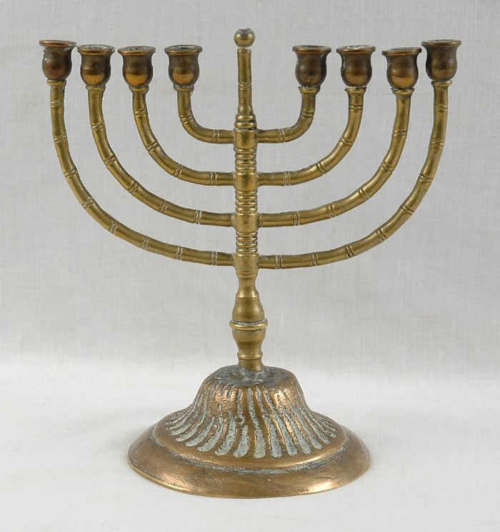
The Hanukkah Menorah that Willy Tal received as a gift for his Bar Mitzvah in Amsterdam in 1935.

The holiday of Hanukkah has come to symbolize the struggle for national revival that Zionism represents. The light of the eight days has become the light of the Jewish state in the land of Israel and the valor of the Maccabees has become a symbol of the national spirit.

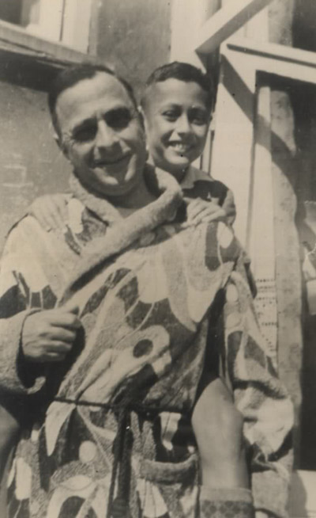
Willy Tal with his father Felix, 1935

With the approach of Hanukkah, we have chosen to highlight the heroism of Willy Tal, whose Menorah was donated to the artifacts collection in October.
Willy Tal was born in Amsterdam in September 1922, the second child of Felix & Greta Tal, a brother to Florry. With the outbreak of war Willy found work with the Jewish Council as a male nurse in the Jewish Hospital for the mentally disturbed “Het Apeldoornse-bos”. This gave him a temporary reprieve from deportation.
On January 21st 1943, by order of Eichmann, in conjunction with Gemmeker, the Kommandant of Westerbork transit camp, some 900 mentally disturbed patients and 500 hospital staff were deported to Auschwitz. Though there was advanced warning of the round up, and some 100 workers went into hiding, Willy refused to abandon his patients and was sent with them to Auschwitz. Willy was murdered there on the 30th of April, 1943.
Willy’s father, Felix, who had understood what the future held upon the occupation of Holland, transferred the family’s valuables, documents and family albums to a room that he rented in Amsterdam. Among these was the Hanukkah Menorah that his son Willy had received as a Bar Mitzva present.
Felix and Greta survived the war in hiding in Amsterdam. At the end of the war Felix collected the hidden family property. In 1947, Greta, her daughter Florry and her son-in-law Eli Asscher immigrated to Israel and brought the Menorah with them.
The Hanukkah Menorah was donated in October 2008 by Florry Asscher to the Yad Vashem’s Artifacts Collection as a final keepsake of her brother Willy who was murdered in Auschwitz.

Reprinted from the website of Yad Vashem. The World Holocaust Remembrance Center in Jerusalem, Israel.

Alexander the Great and the First Miracle of Hanukka
By Rabbi Yosef Bitton

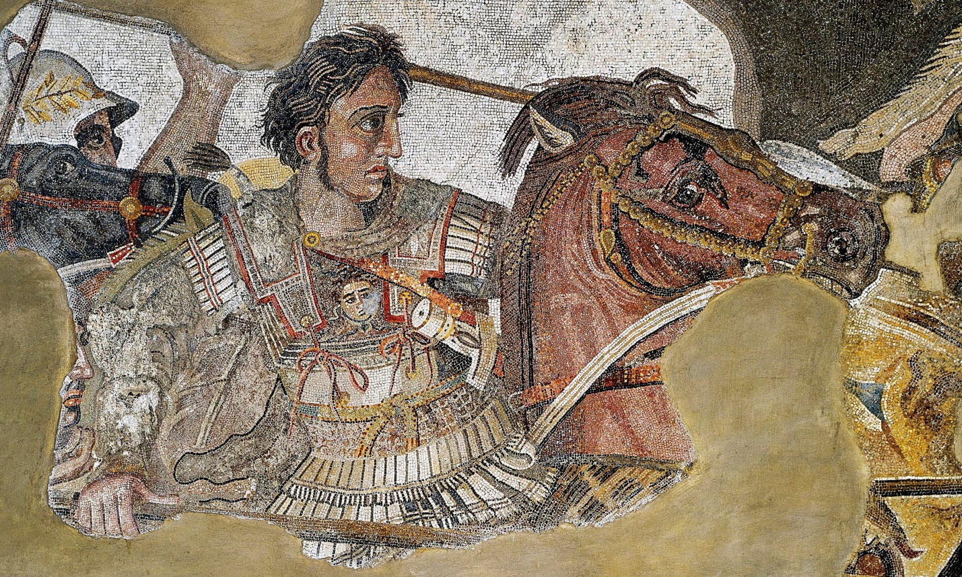

For the Greeks, and for the Romans a few centuries later, it was intellectually (or psychologically) impossible to understand Judaism. They could not conceive that we Jews believe in (and especially that "obey") an invisible G-d: "what is not seen, does not exist", they reasoned.
They also found incomprehensible the Jews' refusal to accept that other gods could coexist with our G-d. What's wrong with placing a statue of my god next to your G-d? Pagan deities did not demand exclusivity of cult! Why should Jews demand it?
Furthermore, in the polytheistic mentality when a people was defeated it meant "that their gods turned out to be less powerful than the gods of the victors." The defeated peoples accepted -pacifically or forcefully- the superiority of the conquering gods, and embrace them, in addition to their own local idols! A new pantheon with a combination of local and foreign deities represented the most diplomatic way to survive the military defeat.
As we can see, the coexistence of several gods was normal at that time. And the Jews' refusal to accept the gods of neighboring peoples was seen as a sign of their arrogance or intolerance.
Only once we understand this, that is, what must have crossed the mind of Alexander the Great when the Jews rejected his request, we are able to better appreciate the magnitude of the miracle that took place in that moment. Now, why is that this great miracle is not better known? I think because it is not something that happened, but something that should have happened and providentially did not happen. That makes it more abstract, elusive, and difficult to identify.
Something else: Like every emperor, Alexander demanded from each people of his Empire to send soldiers to serve in his army. The Jews formed their own battalion that served in the ranks of the Greek army. Alexander ordered that Jewish soldiers be allowed to keep their religion (Kashrut, Shabbat, etc.) while serving in their ranks.
There is also documentation that shows that Alexander the Great instructed his generals to excuse the Jewish soldiers from participating in the construction of a pagan temple in Babylon (E. Bickerman), an act forbidden for Jews.
And a letter was found where Alexander asks to deliver a special Kosher oil to the Jewish soldiers in Antioquia, since they could not use the common oil (ta-me).
Alexander the Great accepted the non-negotiable principles of the Jewish people, and during his short lifetime he became the protector of the Jews of his empire.

Reprinted from the November 27, 2018 Halakha of the Day email from the Shehebar Sephardic Center.

Story #1095

Discovered in Alabama
From the desk of Yerachmiel Tilles
editor@ascentofsafed.com

A young man named Avraham ("Avrumel") Greenbaum lost his entire family in the Holocaust. After the war, he came to America and wanted nothing to do with Judaism. He changed his name to Aaron Green, moved to Alabama and married a woman there, who, miraculously, was Jewish.
The day his oldest son Jeffrey turned thirteen, they were not going to celebrate his bar mitzvah. Instead, Aaron decided to recognize the day by taking Jeffrey to the mall and buying him anything he wanted there.

Jeffrey’s Eye Caught Something
In an Antique Shop
When they went into a big electronics store and were browsing, Jeffrey's eye caught something in an antique shop across the way. He was mesmerized. He couldn't take his eyes off what he had seen.
He told his father, "I don't want anything from the electronics store. I want to go across to the antique shop." When they got there, the boy pointed to an old wooden menorah and said, "That's what I want for my bar-mitzvah."
His father couldn't believe it. He was letting his child buy anything he wanted in the whole mall and this is what he was choosing? He tried to talk him out of it, but couldn't.

Shopowner Doesn’t Want
To Sell the Menorah
Aaron asked the shop-owner the price of the menorah. To his surprise, the man replied "Sorry, that's not for sale."
Aaron said, "What do you mean? This is a store." He offered a lot of money for it.
Again the owner refused, this time explaining, "I found out the history of this menorah. A man constructed it during the war and it took him months to gather the wood. It survived, but he did not. It's going to be a collector's item. It's not for sale."
Meanwhile, Jeffrey kept telling his father, "That's what I want. All I want is the menorah." So Aaron Green kept offering more money until the owner finally agreed to sell.
The boy was so excited. He took the menorah up to his room and played with it every day. One day the parents heard a crash from Jeffrey's room. They ran upstairs and saw the menorah shattered to pieces. The father yelled at his son for being so careless, as he paid so much money for it.
Afterwards, Aaron felt bad about his reaction. He suggested to his son, "Let's try to glue it back together."

Father Notices a Piece of Paper Wedged Inside
While holding one of the pieces, the father noticed a piece of paper wedged inside. He pulled it out and started reading. Tears welled up in his eyes and soon after he fainted.
His family threw water on him and revived him. "What happened?", they asked.
He replied, "Let me read you this letter. It was written in Yiddish, so I'll translate.
"To whoever finds this menorah, I want you to know that I constructed it not knowing if I would ever have the opportunity to light it. Who knows if I will live till Chanukah to see it being kindled? In all probability, going through this war, I will not. But if Providence brings this menorah to your hands, you who are reading this letter, promise me you will light it for me and for us, my family, and those who gave their lives to serve G-d Al-mighty."
Aaron Green then looked up at his family and, in a choked-up voice with tears still in his eyes, said, "The letter is signed by my father."
They were all speechless. That family recognized the Divine Providence involved and they returned to living their lives according to Torah and mitzvot. How could they not! The hand of G-d was undeniable, taking a menorah from Europe and bringing it back to the family in a remote mall in Alabama, inspiring them to return to Torah-true Judaism.
~~~~~~~~~~~~~~~~~~~~~~~~
Source: Adapted by Yerachmiel Tilles from a submission by Chayim Berkowitz of Tsfat (formerly of Miami), who received it from Yosef Hurwitz, whose son-in-law and daughter, Rabbi Yosef and Mrs. Binah Goldwasser, are the co-directors of "Chabad of Mobile" and heard it from the family.
[Author's concluding paragraph:] Chanukah means to re-dedicate. It's a time to rededicate ourselves and come closer to the Creator.

Reprinted from the 5779/1918 Chanukah email of KabbalaOnline.org, a project of Ascent of Safed.
In Holland, One of the World’s Most Expensive Hanukkah Menorahs Hides in Plain Sight
By Cnaan Liphshiz

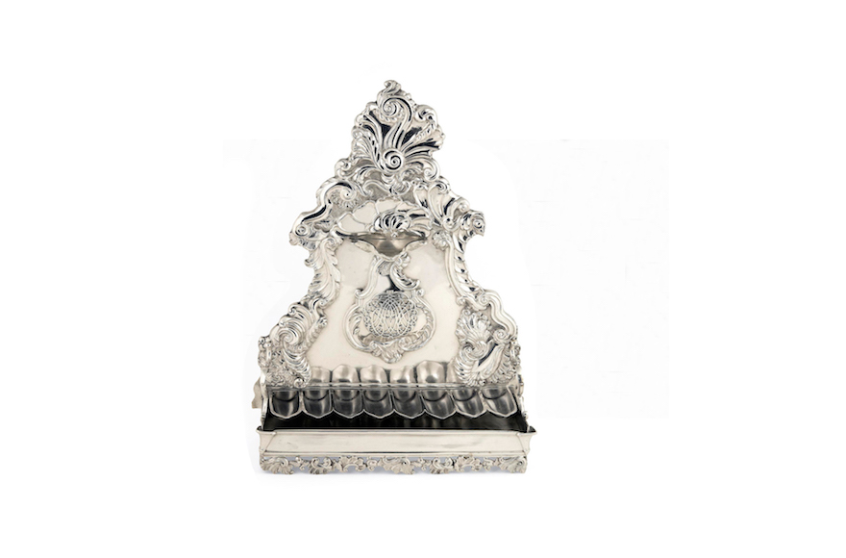
Despite its humble appearance, The Amsterdam Jewish Historical Museum’s Nieuwenhuys menorah is worth more than many of the city’s houses. (Courtesy of the the Amsterdam Jewish Historical Museum)

AMSTERDAM (JTA) — Nothing about the appearance of object MB02280 at this city’s Jewish Historical Museum suggests it is the capital’s priciest Hanukkah menorah, worth more than the average local price of a duplex home.
Shaped like the body of a violin, it is only 16 inches tall. Its base cradles eight detachable oil cups intended to function as candles on Hanukkah, when Jews light candles to commemorate a 167 BCE revolt against the Greeks. They are set against the menorah’s smooth, reflective surface, whose edges boast elaborate rococo reliefs.
But for all its charms, the Nieuwenhuys menorah — its creator was the non-Jewish silversmith Harmanus Nieuwenhuys — doesn’t stand out from the other menorahs on display next to it at the museum. Far from the oldest one there, the menorah certainly doesn’t look like it’s worth its estimated price of $450,000.
The Nieuwenhuys menorah can hide in plain sight because its worth owes “more to its story than to its physical characteristics,” said Irene Faber, the museum’s collections curator.
Made in 1751 for an unidentified Jewish patron, the Nieuwenhuys menorah’s story encapsulates the checkered history of Dutch Jewry. And it is tied to the country’s royal family, as well as a Jewish war hero who gave his life for his country and his name to one of its most cherished tourist attractions.
The price tag of the Nieuwenhuys menorah, which does not have an official name, is roughly known because a very similar menorah made by the same silversmith fetched an unprecedented $441,000 at a 2016 auction. A collector who remained anonymous clinched it at the end of an unexpected bidding war that made international news. It was initially expected to fetch no more than $15,000.
Another reason for the more vigorous bidding: The menorah came from the collection of the Maduros, a well-known Portuguese Jewish family that produced one of Holland’s most celebrated war heroes. The Nazis murdered George Maduro at the Dachau concentration camp after they caught him smuggling downed British pilots back home. In 1952, his parents built in his memory one of Holland’s must-see tourist attractions: the Madurodam, a miniature city.
“I imagine the connection to the Maduro family drove up the price,” said Nathan Bouscher, the director of the Corinphila Auctions house south of Amsterdam, which has handled items connected with famous Dutch Jews.
Besides the menorah on display at the Jewish Historical Museum, the Netherlands has another very expensive one in the Rintel Menorah: A 4-footer that the Jewish Historical Museum bought last year for a whopping $563,000. Far more ostentatious than the modest-looking Nieuwenhuys menorah, the Rintel, from 1753, is made of pure silver and weighs several kilograms. It is currently on loan to the Kroller-Muller Museum 50 miles east of Amsterdam.
The Jewish Historical Museum has no intention of selling the Nieuwenhuys, Faber said, although it could attract even more spectacular bids owing to its provenance: It was bought by the late queen of the Netherlands, Wilhelmina, as a gift for her mother and given to the museum by her great-grandson, King Willem-Alexander.
“We don’t know who commissioned the work, but from the reputation of the artist and the amount of labor it took, it was probably a wealthy Jewish family, perhaps of Sephardic descent,” Faber told JTA last week at the museum.
At the center of the object is a round network of arabesque-like decorations “that probably contains the owner’s initials in a monogram,” Faber said, “but we haven’t been able to decipher it. It’s a riddle.”
The monogram was one of several techniques that Nieuwenhuys and other Christian silversmiths in the Netherlands had developed for their rich Jewish clients.
Before the 19th century, no Jews were allowed to smith silver in the Netherlands because they were excluded from the Dutch silversmiths guilds, which were abolished in the 1800s.
“This exclusion was beneficial [to the guild] because it kept out competition, but it meant that Christian smiths needed to become experts at making Jewish religious artifacts like this menorah,” Faber said.
Works like the menorah on display at the museum illustrate how some Jewish customers clearly were art lovers with sophisticated tastes.
Whereas the Maduro menorah was symmetrical with Baroque highlights, the Nieuwenhuys is asymmetrical with rococo characteristics that were “pretty avant-garde for its time,” Faber said. The smooth surfaces are “another bold choice, showing finesse,” she added.
Whoever owned the menorah no longer possessed it by 1907, when Queen Wilhelmina bought it for an unknown price at an auction to give it as a gift to her mother, Princess Emma.
This purchase may appear inconsequential to a contemporary observer, but its significance becomes evident when examined against the backdrop of institutionalized anti-Semitism among other European royal houses and governments.
The German Emperor Wilhelm II, a contemporary of Wilhelmina, was a passionate anti-Semite who famously said in 1925 that “Jews and mosquitoes are a nuisance that humankind must get rid of some way or another,” adding “I believe the best way is Gas.”
Belgium’s King Leopold III was more politically correct, stating magnanimously in 1942 that he has “no personal animosity” toward Jews, but declaring them nonetheless “a danger” to his country. He raised no objections when the Germans and their collaborators began deporting Belgian Jews to their deaths.
In countless wartime broadcasts, Queen Wilhelmina of the Netherlands rallied the Dutch but mentioned Jews only three times. (National Archive of the Netherlands)
But in the Netherlands, where thousands of Jews found haven after fleeing the Spanish and Portuguese Inquisition of the 16th century, royals not only refrained from such statements but were genuinely “interested in other faiths, including the Jewish one,” Faber said.
Wilhelmina’s gifting of a menorah to her mother “isn’t strange for her,” Faber said. “I imagine she found it fun, something to talk about with her mother, to see together how it works.” After all, “Jews have always been under the protection of the Royal House.”
Except, that is, during the years 1940-45, when Queen Wilhelmina and the Royal House fled to the United Kingdom. Wilhelmina mentioned the suffering of her Jewish subjects only three times in her radio speeches to the Dutch people during five years of exile.

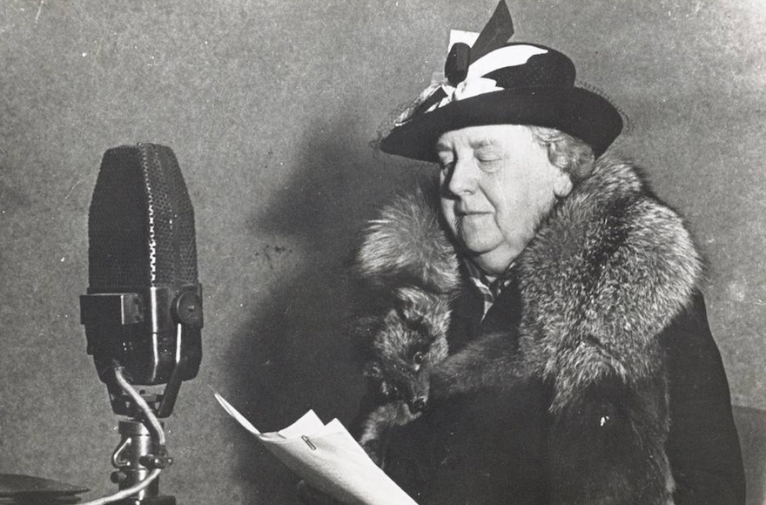

Whereas before the war “Jews always sought the Royal House,” during and after “it appeared Wilhelmina didn’t think too much about the Jews,” Faber said. This was “a stain” on relations between Dutch Jews and the Royal House, which underwent a “rupture.”
But this was gradually healed in the postwar years.
The fact that King Willem-Alexander, Wilhelmina’s great-grandson, in 2012 gave the Nieuwenhuys menorah on an open-ended loan to the Jewish museum on its 90th anniversary “symbolizes the healing of the rupture,” Faber said.
Cnaan Liphshiz Cnaan Liphshiz is based in the Netherlands, where he reports on Jewish life throughout Europe. Born in Israel, he previously worked as foreign news editor for Maariv and as a reporter for Haaretz.

Reprinted from the November 13, 2018 dispatch of the JTA (Jewish Telegraphic Agency.)

Jewish Girl Teaching the Late President George Herbert Walker Bush How to Play with the Hanukah Dreidel
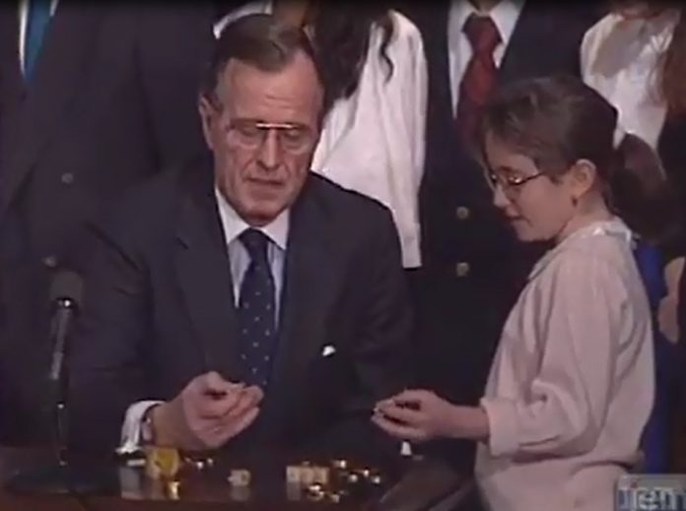
This photo was taken around Chanukah sometime between 1989 -1992. Reprinted from a video of JEM – google When President Bush played dreidel - COLLIVE
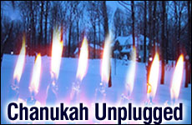
By Carol Tice

Our Chanukah candles shone extra-bright last year. That's because they were the only lights in our house.

The day of Chanukah eve, the Seattle area was visited by a vicious windstorm (officially named "The Chanukah Eve Windstorm" by a National Weather Service contest). About a million homes lost power, including nearly every home on our island of 24,000. Near our home toppled trees blocked roads and beheaded telephone poles left their electric wires in tangles on the ground. Our guess was the power wouldn't be restored anytime soon.
With schools, child care and my work day all canceled and the temperature in the mid-30s, I started planning how to make our first night of Chanukah celebration -- and Shabbat dinner -- without electricity.
Fortunately we have a woodstove and can heat much of our house and cook atop it, so we weren't going to freeze or starve. Milk and other perishables went into coolers on the deck, preserved by the cold outside.
Challah I had baked the week before came out of the rapidly defrosting freezer to be warmed on top of the stove. We wrapped salmon in aluminum foil and baked it on the coals. Gelt and a chocolate orange we'd been given as a gift would be our simple dessert. With store shelves in town rapidly emptying, and warnings to stay off the roads both for safety and to conserve scarce gasoline, we would eat what we had.
I had already gathered the things I needed for Chanukah -- menorah, candles, gelt, dreidels, Chanukah storybooks. There wouldn't be any frying latkes or doughnuts (we couldn't get the oil hot enough on the woodstove), or Chanukah music CDs or Chanukah videos, but we had the basics.
Lighting that tiny Chanukah candle in our cold, darkening kitchen left my two preschoolers in hushed awe. On our wooded street, our neighbors' homes were nearly invisible in the dark. We sang our Chanukah songs without accompaniment -- "Mi Yimalael" (Who Can Retell The Things That Befell Us) was an obvious choice here -- and my three-year-old daughter Ariella even made up a few Chanukah songs of her own.
Seeing those small lights in our darkened home made me feel transported back in time. I understood for the first time, on a deeper level, the small glimmer of hope the Maccabees must have felt lighting the menorah in the restored Temple, praying that somehow their tiny pool of oil would last over a week, until more fuel could be made.
I thought of the simple Chanukahs my great-grandparents likely celebrated back in the pre-electricity days in their small town of Lvov, Poland. Those nights may well have been much like this one, cold and dark, lit only by candles and by the simple joy of celebrating our freedom to worship as Jews.
With our electronic distractions gone, the whole evening seemed to take on a magical, intimate quality.
With our electronic distractions gone*, the whole evening seemed to take on a magical, intimate quality. We told the Chanukah story from memory, huddled together for warmth in the orange glow of the woodstove. My preschoolers were even good sports when their small gifts for the night turned out to be messy modeling clay they couldn't play with until morning brought more light.
As night fell, our lights were increased by Shabbat candles. We ate some of the most delicious tangerines I've ever tasted for our first Shabbat course. Sitting by jet-black windows unlit by street lamps, all agreed this was certainly the most wonderful challah I had ever baked. Each dish tasted exquisite, its warmth an amazing gift.
With our bedrooms closed off and cold, we and our three children talked, cuddled, and played into the night, then curled up on couches and in sleeping bags around the still-warm stove together to spend the night. Our second night of Chanukah passed in much the same way.
A week later, some of our friends still didn't have their power back on, including our rabbi. Some areas of Seattle went two full weeks before power was restored.
We were more fortunate. Though we were braced for an entire Chanukah week without power, our lights came back on just over two days after they'd flickered out.
Moving around my house switching on lights, listening to the comforting sound of my heater warming up, I realized I was living my own miracle of Chanukah -- the miracle of light where I thought there would be none. The miracle of ending up with one of the most memorable Chanukahs my family ever had, despite the hardships.
This year, I'm thinking maybe we'll turn off all the lights and do it all again. I think Chanukah just won't be as inspiring without those tiny candle flames standing brave and alone against the dark.
*Luckily we had the additional light of our woodburning stove as Jewish law prohibits making ordinary use of the light given off by the Chanukah candles.
Carol Tice is a mother of three, reporter and teacher who lives on Bainbridge Island, Wash.

Reprinted from the Aish.com website. Originally published on December 1, 2007.

